

VISN 5 Use and Configuration Guide for AssetWorx! 4.0.8.7

Document Control
Document Title | VISN 5 Use and Configuration Guide for AssetWorx! VA
Version | 1.3 (February 2026)
System Version | AssetWorx! VA 4.0.8.7
Authors | Eddy Pritchard (IDI), Gene Anderson (IDI), Brittnay Heishman (Impres), John Guempel (IDI)
Owner | VISN 5
Classification | Internal – VA Operational Use

Revision History
Version | Date | Author | Summary of Changes
1.3 | February 2026 | J. Guempel / E. Pritchard | Updated to reflect current offline process

OEM Support
Role | Name | Email
Engineer | John Gumpel | jguempel@id-integration.com
CEO | Gary Moe | gmoe@id-integration.com

TABLE OF CONTENTS
Running ADHOC 4
How to Use Offline Printing Station 7
How to Set Up Zebra TC53 With Sled 13
How to Install AssetWorx! on a TC53 16
How to use Batch Mode Scanning 23
How to Use “Locate” Feature on Zebra Sled Reader 30
How to Adjust Power on Zebra Sled Reader 34
Missing Location Tag: What do I do now? 37
How to Use the Logout Feature on Zebra Sled Reader 39
How to Use the ENNX Report Generator 41
Summary: 41
ENNX Report: 41
Open and Login to the ENNX Report tool - 41
Exporting ENNX Reports - 44
Configuring ENNX Reports - 45
Basic Settings for RFID Printers…………………………………….………..46

Running ADHOC
Run AdHoc in Above PAR report to create the “EQUIPMENT.xlsx” excel sheet template with desired EE tag information.
Below is the precise AdHoc Field Selections and Order number needed to pull this Report.
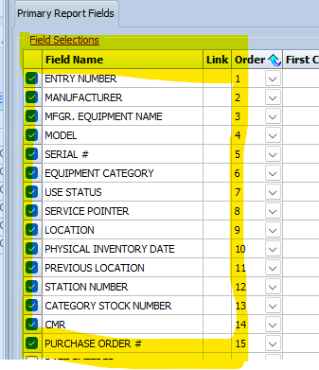
Example A: By putting in First Condition with EE number you will only pull that EE number. If you put in a Second Condition with EE number, it will pull Two EE numbers. If you do not put any conditions, it will pull every EE number in the system.
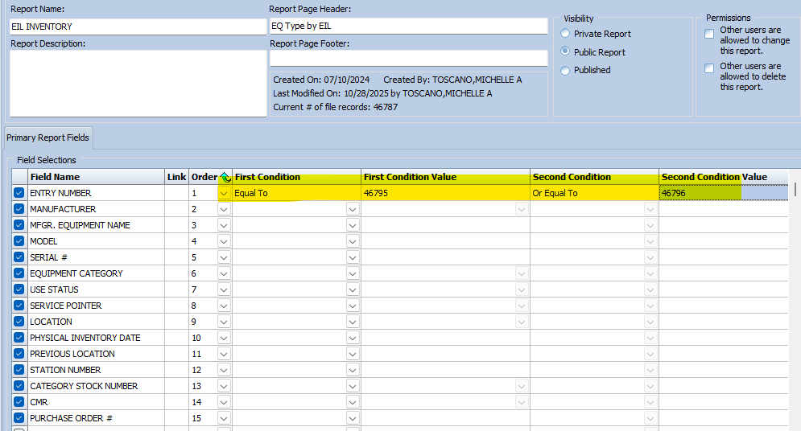

Example B: First condition as Greater Than, and the EE number before the EE number you want through to the last created EE number. (if you want to start at EE46795, put in EE46794)
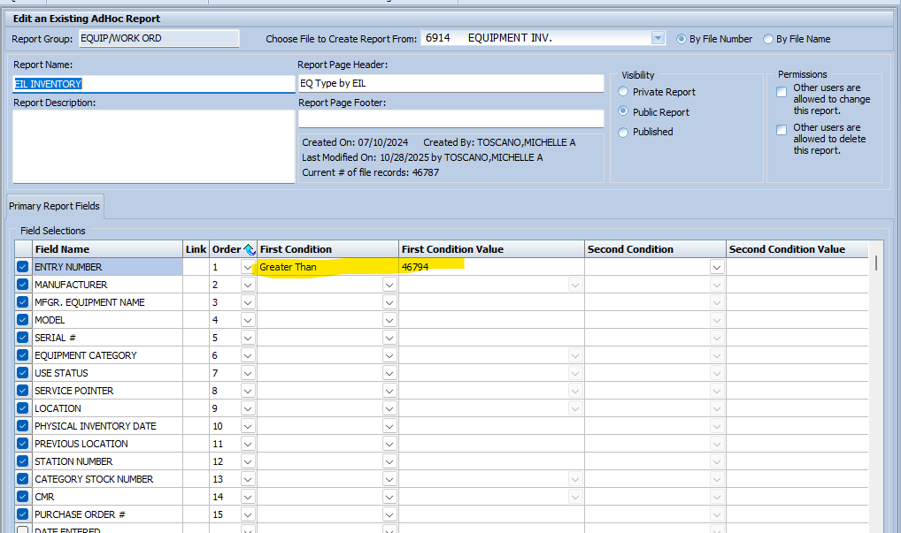

Example C: If you need to pull EE numbers by Date Entered, add Date Entered Field Selections, add First Condition as Equal to and the date you created the Equipment. However, after you pull the report in excel you MUST Delete the Date Entered Column before emailing it to visn5baltimore@id-integration.com!
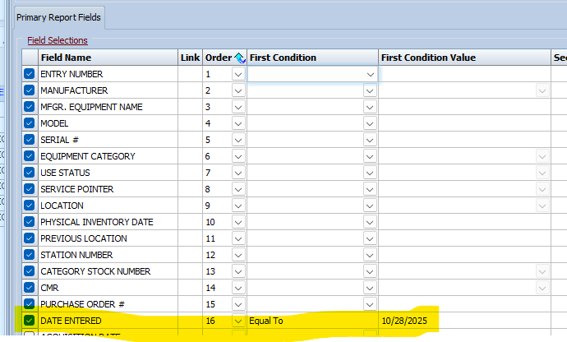

After running the AdHoc report Click on Excel, this will be the excel you will e-mail. 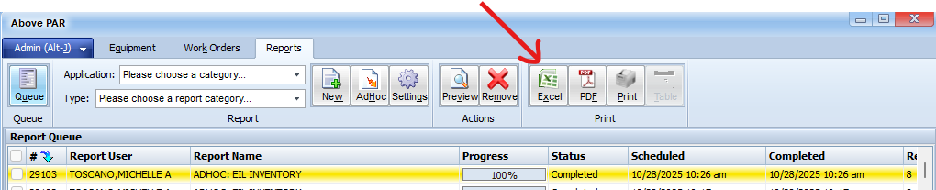

Or Click on Preview to check what was pulled first, then click on Excel
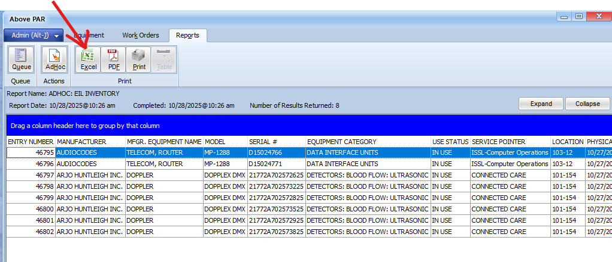

On the Excel, change tab name to SHEET1, Change and save file name as EQUIPMENT.XLSX
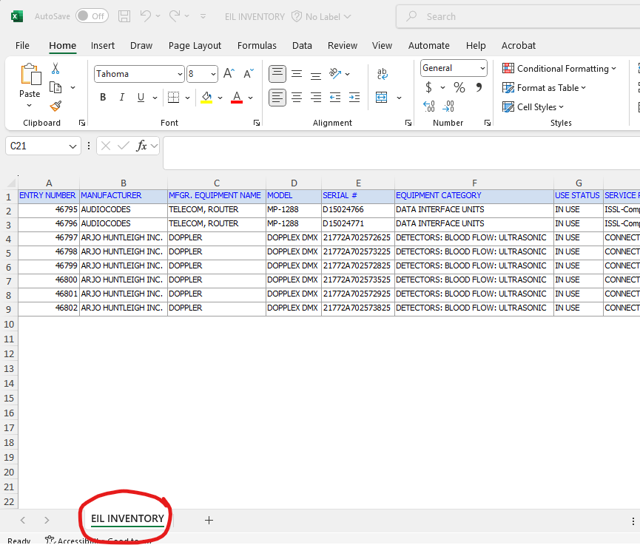
Now you are ready to Send an email to visn5baltimore@id-integration.com and attach the Excel you just created.

How to Use Offline Printing Station

- Go to the printing station and open Microsoft Outlook.
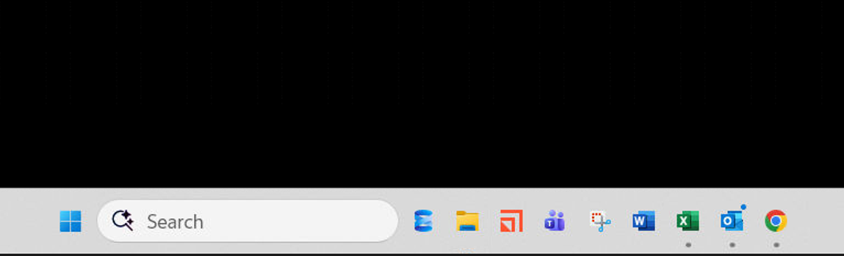

- Select the new email and click on the dropdown arrow - select “Save As” as in the example below
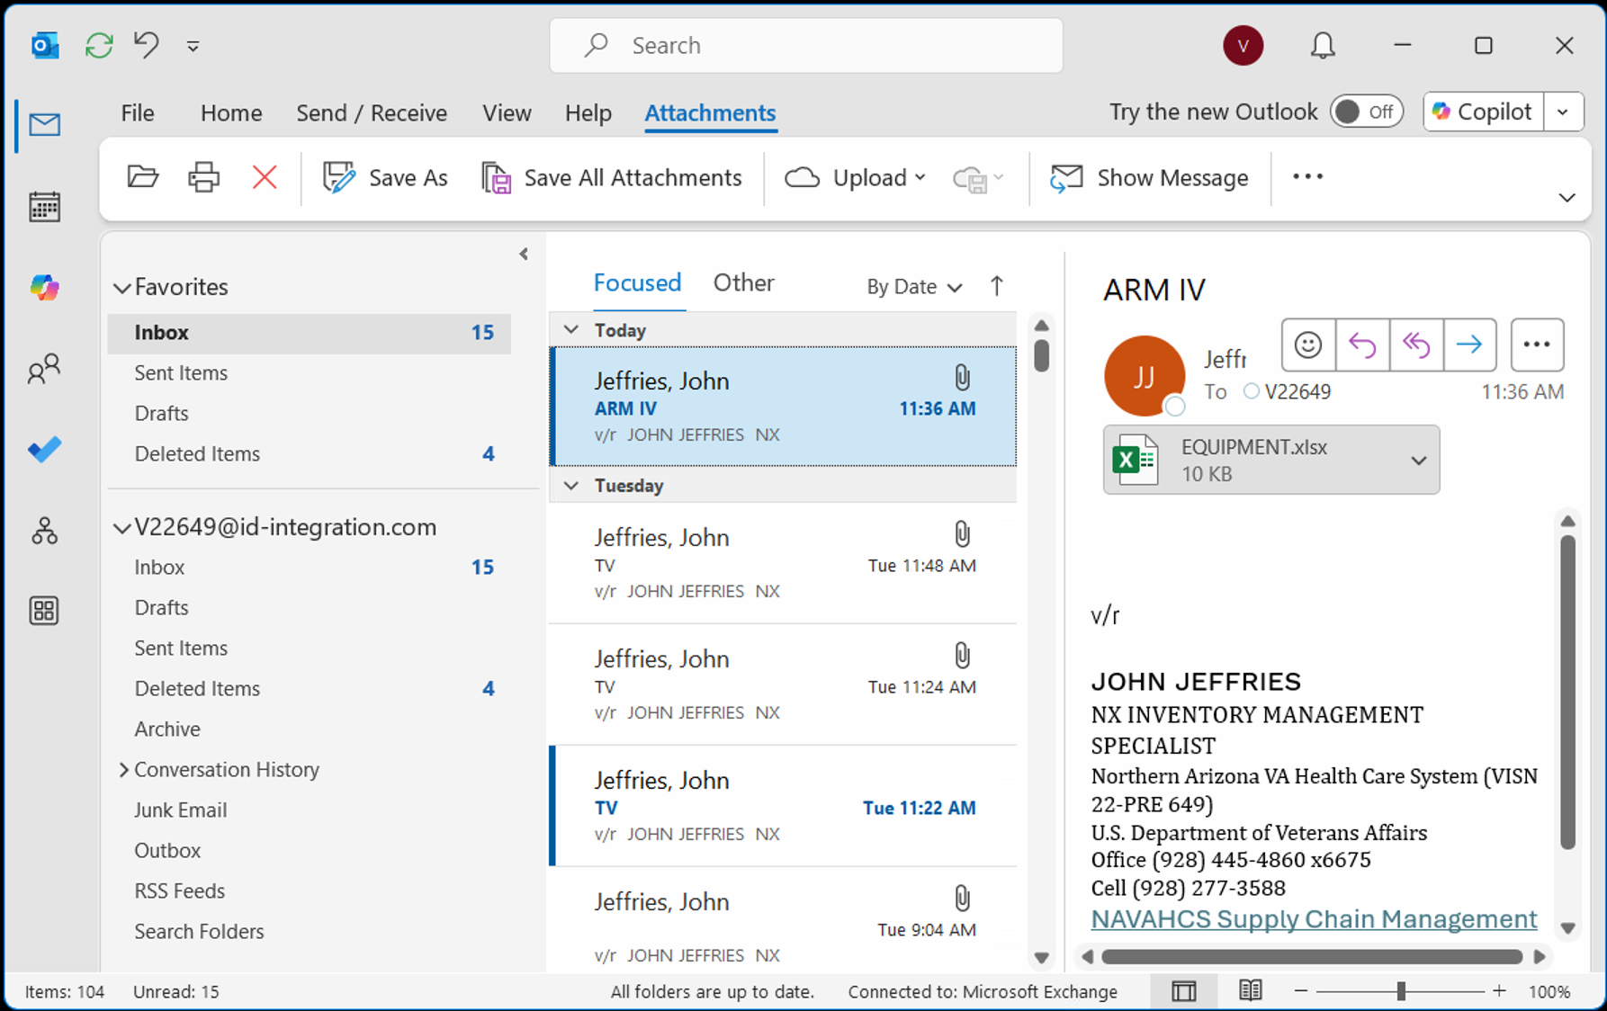

- Next, find and click on “Local Disk (C:) à VA_RFIDà PRINTING” There is a shortcut for your convenience on the desktop. We will use “Email Printing” as the example here.

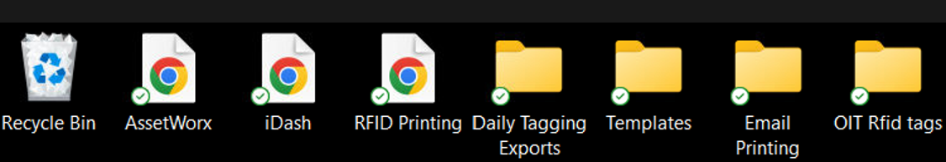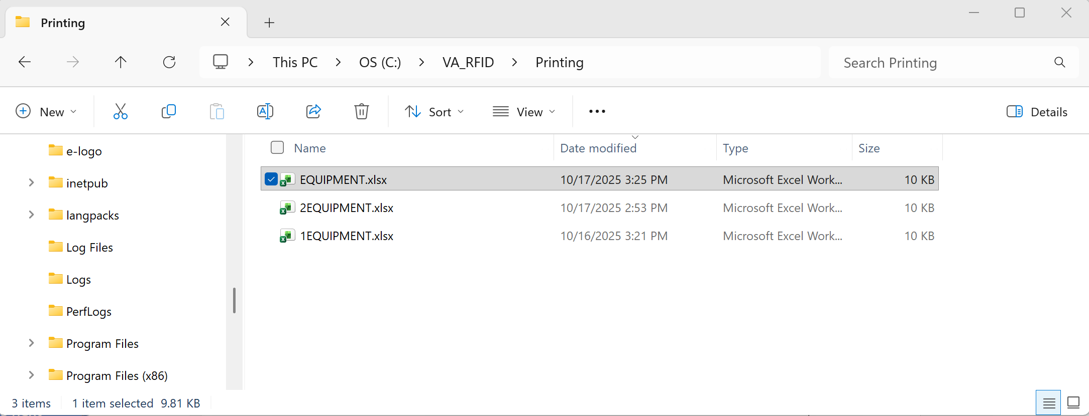
This existing file with the same name will get renamed in the next step.

  - You must save this file as “EQUIPMENT.xlsx” for the template to print correctly.
  - Rename or delete any existing file with the name “EQUIPMENT.xlsx”
Now you can save the new “EQUIPMENT.xlsx” file.
Just a reminder there can only be one file named “EQUIPMENT.XLSX” in the folder. Rename any others.

- Open “RFID Printing” by selecting the application icon in the Desktop as shown in the example below.

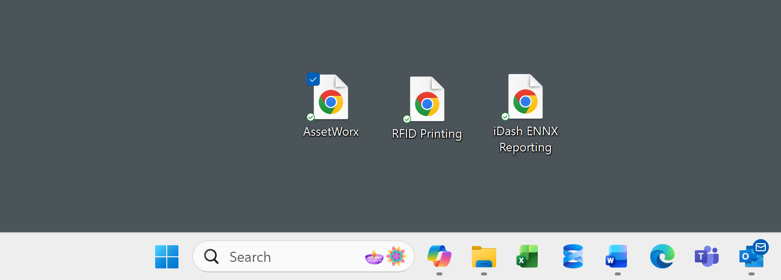

** Baltimore currently has 3 printing categories to accommodate different situations.
- Daily Scans Tagging (Scanning equipment for inventory or for EIL Locating)
- Email Labels (Items created by users and emailed to print station to be printed)
- Supply Chain (Reprint labels)

- Once open, click on a category. In this example we will use “EMAILED LABELS”.

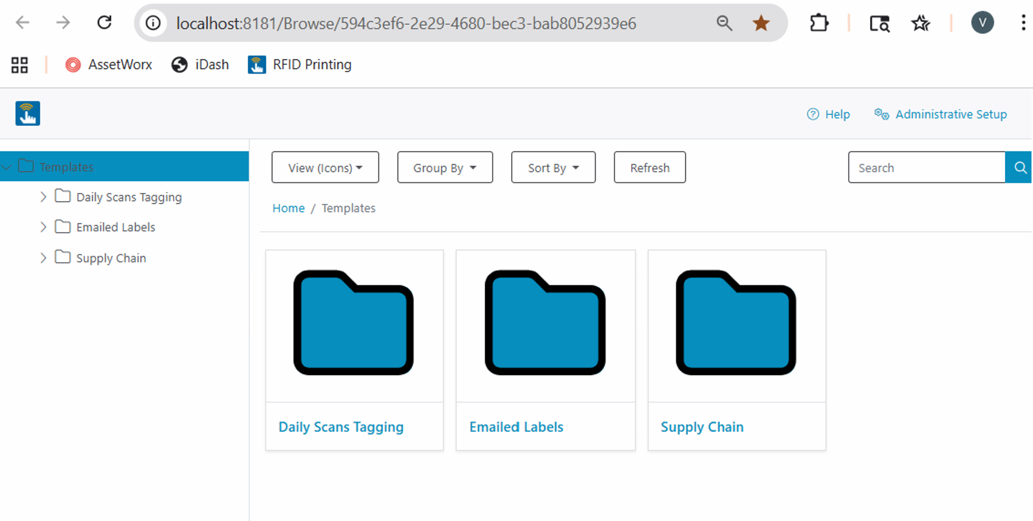
- You will now see 4 label options to choose from. Large_Excel, Small_Excel, Std_Small_Excel, and Q350_Excel.

Choose your desired tag type and click on it. In this example we are going to select Large_Excel label to print. Click on Large_Excel.

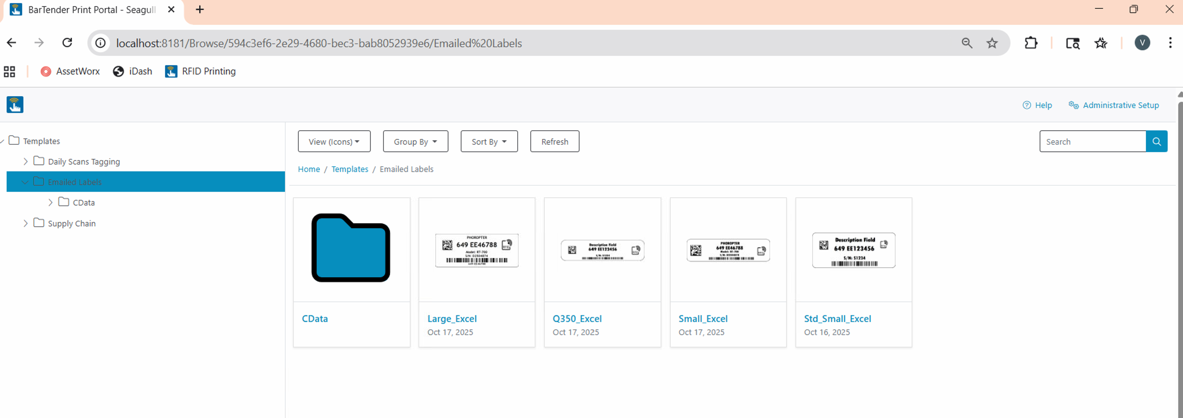
*Note that Std_Small is thin

- Next you will see a screen displayed like in the example below. Click “Print”
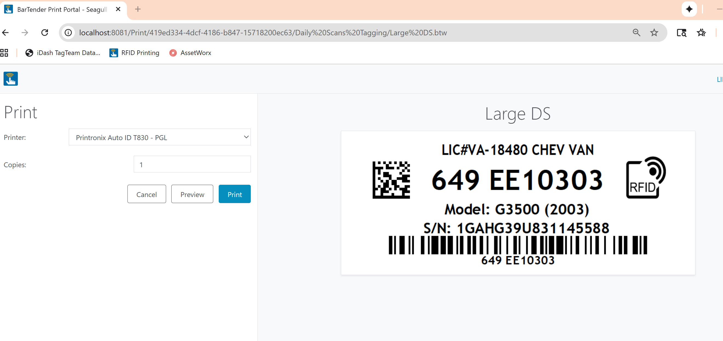

- Select items you would like to print by checking the box to the left as shown in the picture below. Alternatively, you can print all by selecting the top box. Next click “Print”
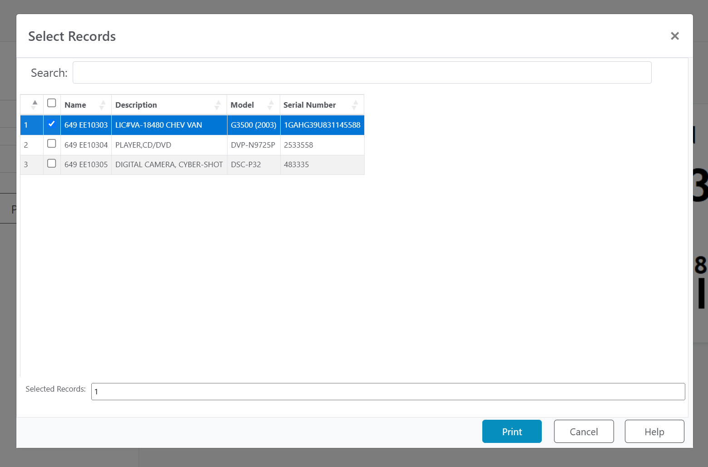

- Apply the laminate on to your label using the overlaminates provided for each tag type.
- After printing, if you would like to print a different tag type, click “Close”, and then click “Cancel”.
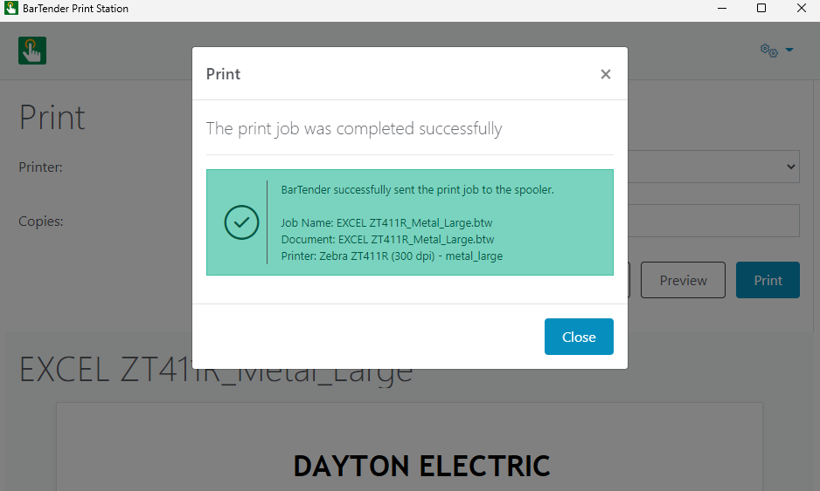
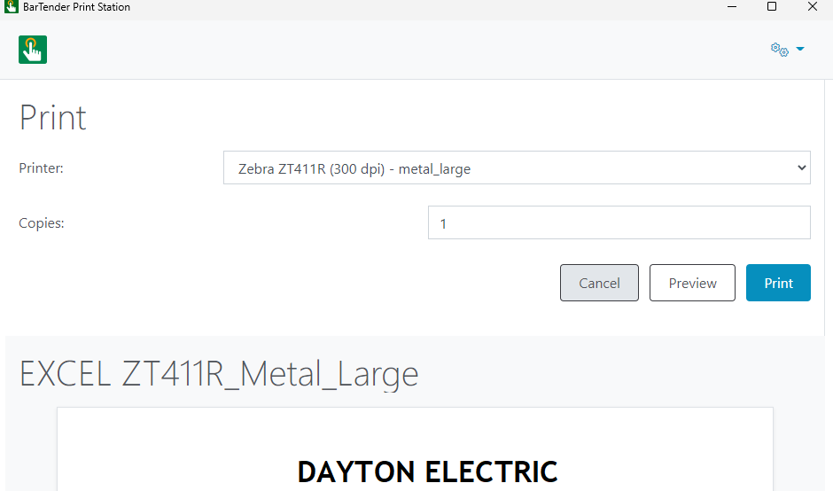

- After selecting cancel you will be brought to the page seen below where you select the next tag type to print.
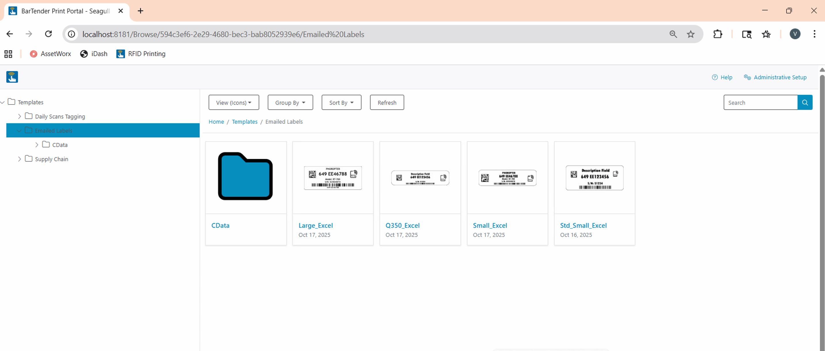
This process continues for each category of printing you will use.

How to Set Up Zebra TC53 With Sled
For AssetWorx! VA to work correctly, make sure the site laptop used to print, and the TC53 RFID reader are connected to your vendor provided MiFi wireless network. Also, make sure the Zebra Sled is connected via Bluetooth.

- Follow these instructions to connect Wi-Fi and make sure you are ready to install AssetWorx! VA

Connect
Click on Settings Icon Click on Network & Internet
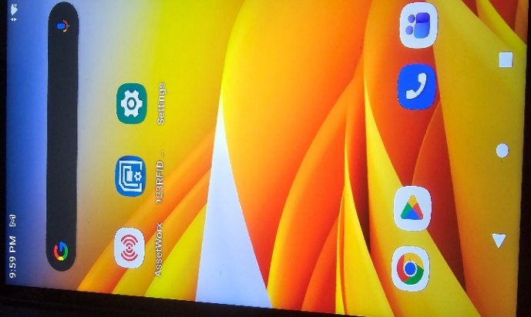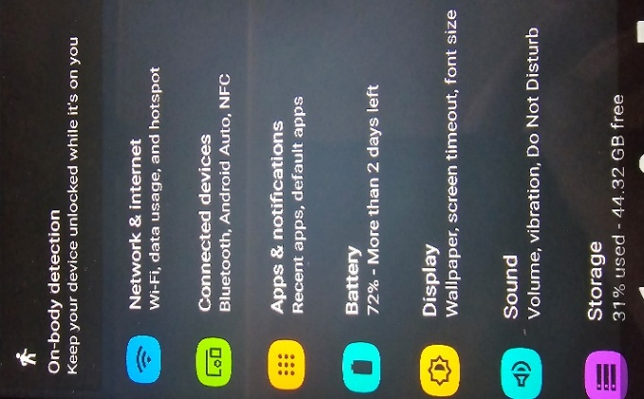
Initial settings screen will be presented
Settings menu will be used to configure many different items

Select “Wi-Fi” Find and choose network to connect to
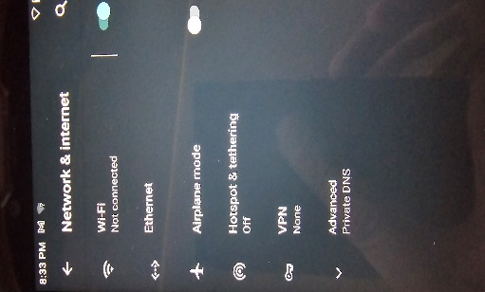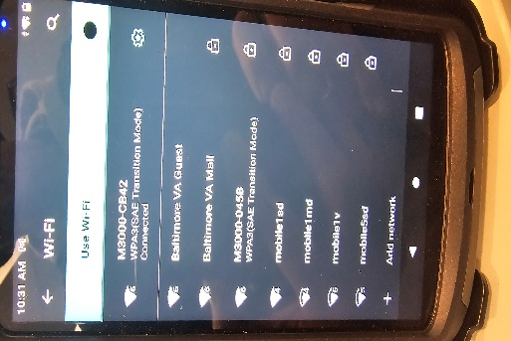
Your MiFi device will be named M3000-xxxx
Scroll up to see “Network and Internet” settings

The Wi-Fi network used at the VA is called “M3000- xxxx”

- Once connected to Wi-Fi you are ready to connect the Sled.

Copy down Sled S/N Click Swettings
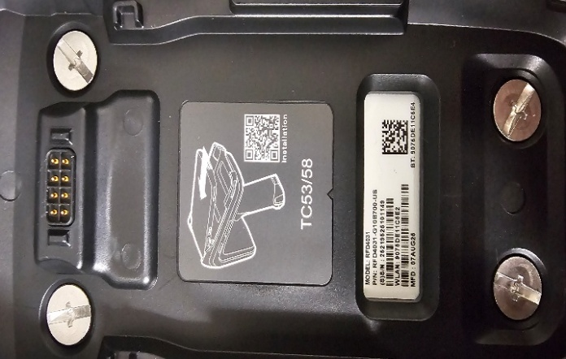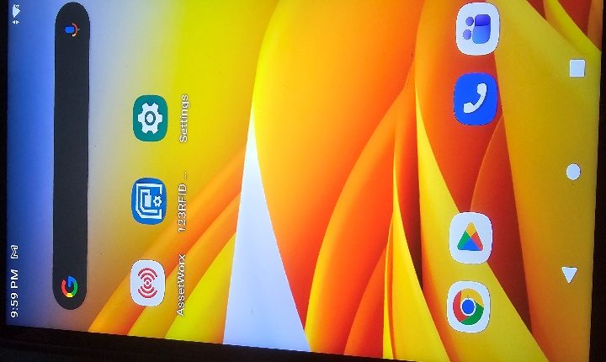

Click “Connected Devices” On sled press trigger to enable Bluetooth Discovery
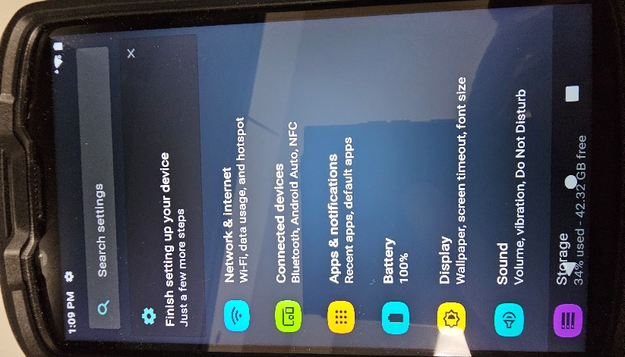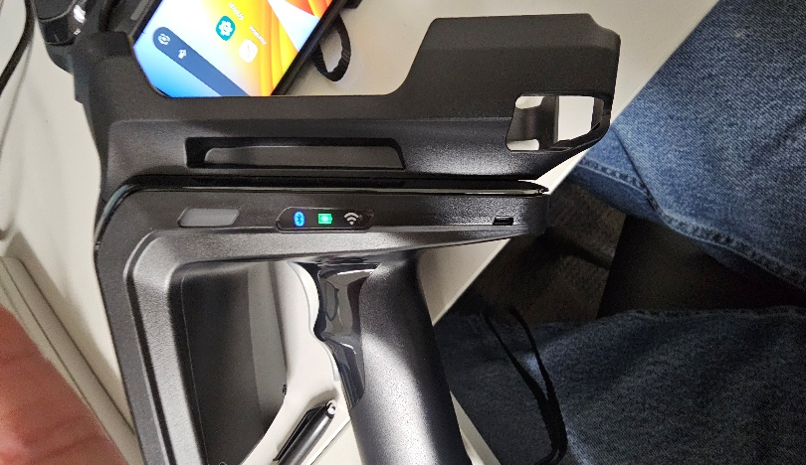

Flashing Blue light, ready to pair Click “Pair new device”
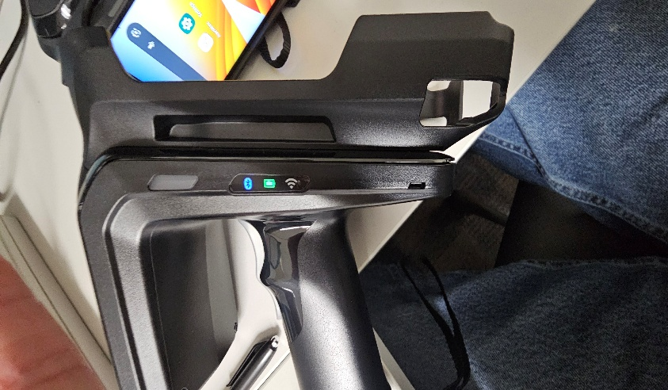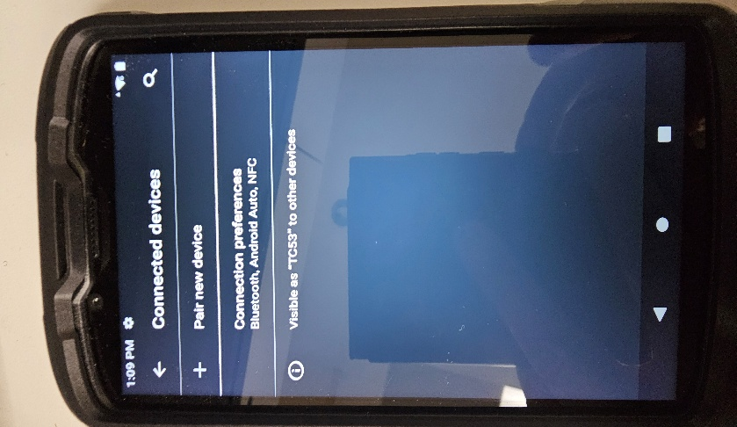

Scroll down until you find sled RF40 with copied S/N Click on correct RF40 Sled
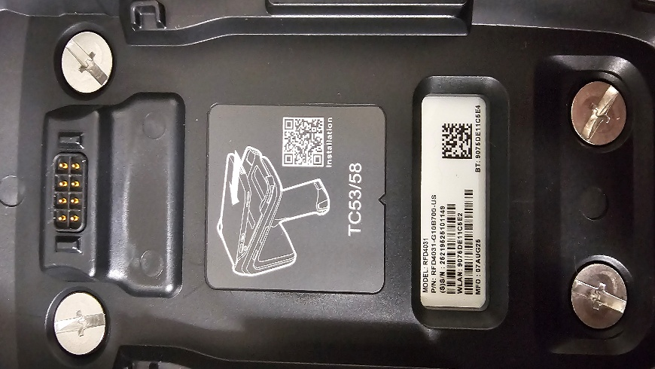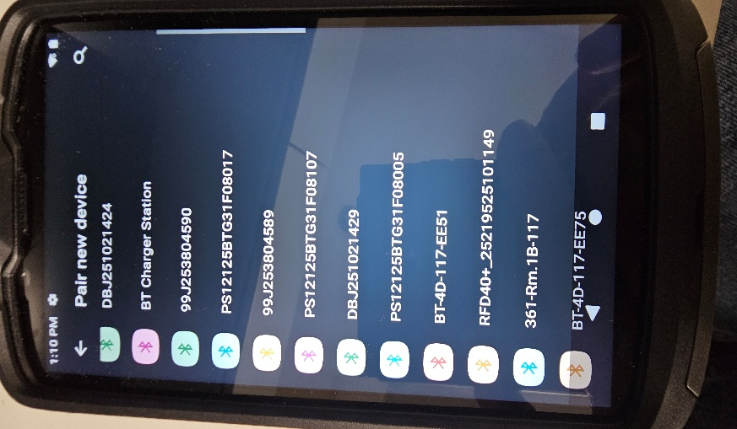

Click “allow” then “Pair” When paired you will see device, close settings
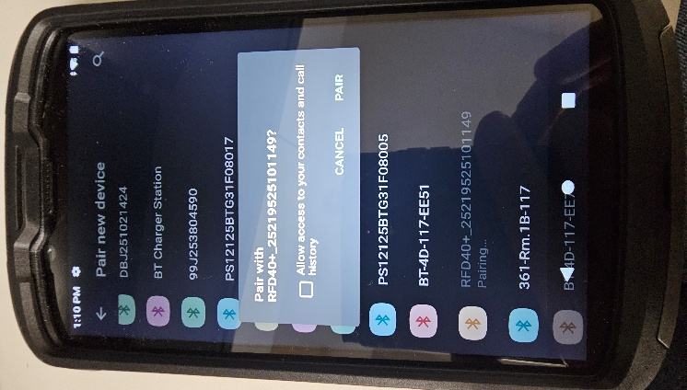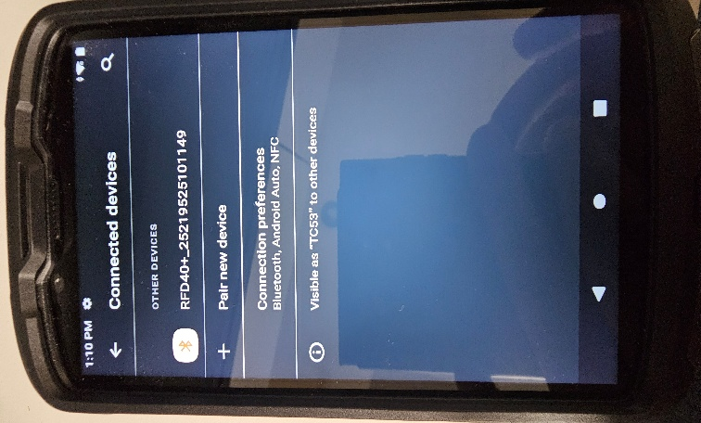

If scanner disconnects when Assetworx! Is opened, Remove TC53 from sled and scanner will reconnect. Reattach TC53 to sled after it connects. Verify scanner is connected by clicking on ‘More” then “Connect Scanner” It will show scanner already connected at bottom of screen. If sled still does not connect, do above steps, remove battery from sled, reinsert battery, after removing TC53.

How to Install AssetWorx! on a TC53

* If AssetWorx! VA Mobile Application is installed on your reader, follow steps 1-3 then skip steps 14-17 below.
* If AssetWorx! VA Mobile Application is not installed on your reader, start on step 4 in this document. This process will be followed should you need to update the application in the future. Support is available and will walk you through this process if necessary.

- Assetworx and Install

Click Google Play Store Click Search and enter Assetworx select
Select Assetworx VA, Click Install.
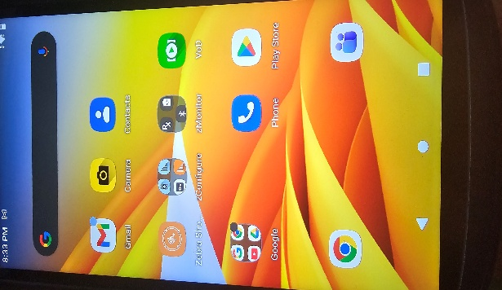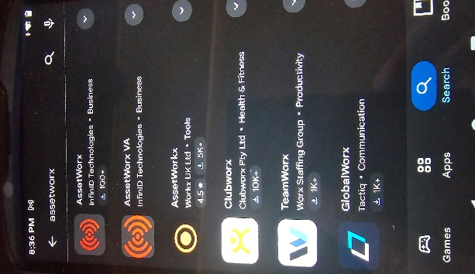

- Once Assetworx is installed, close Google Play Store
- If you need to find your “Server Address”, click on the start button (See picture below)
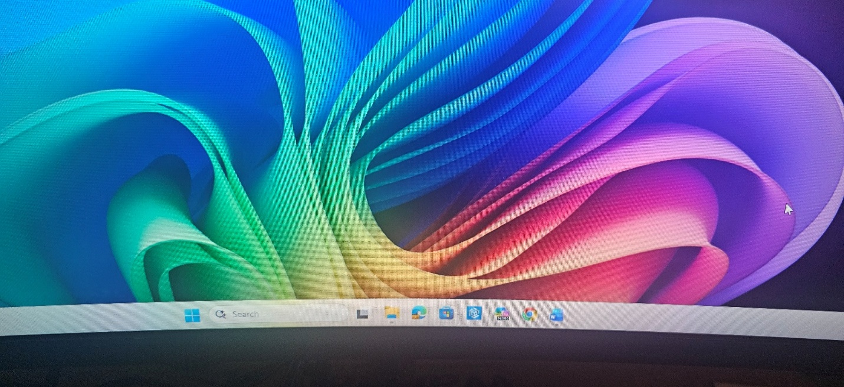

- Type “cmd” in the search bar and select the “Command Prompt” Search Bar, click on Command Prompt System
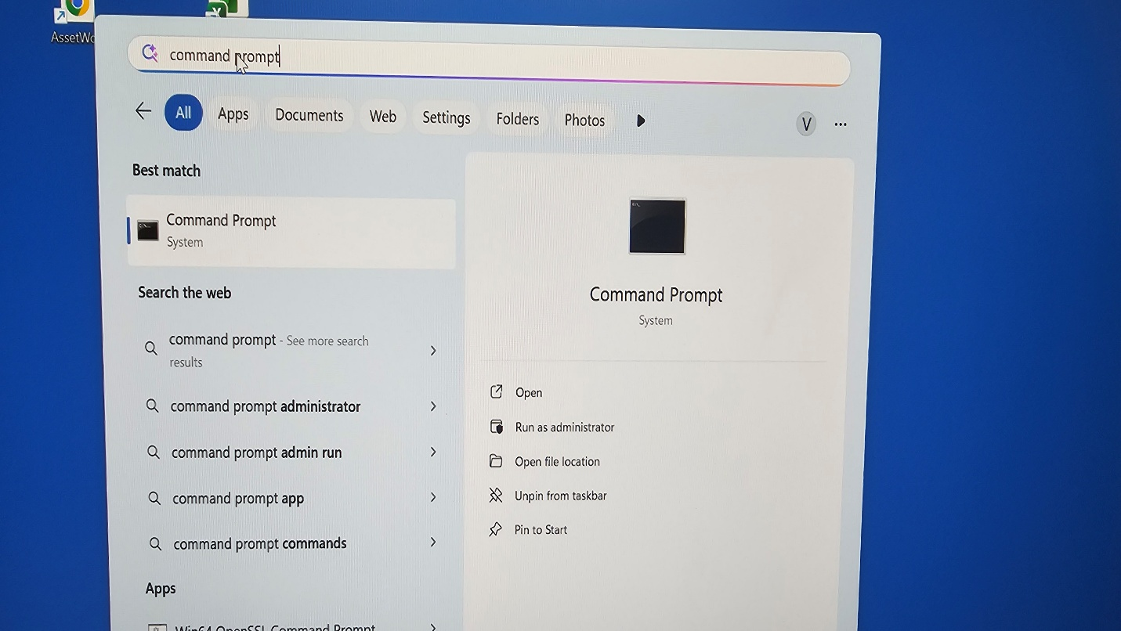

- At the “Command Prompt” window, type “ipconfig /all” and press “Enter” on your keyboard
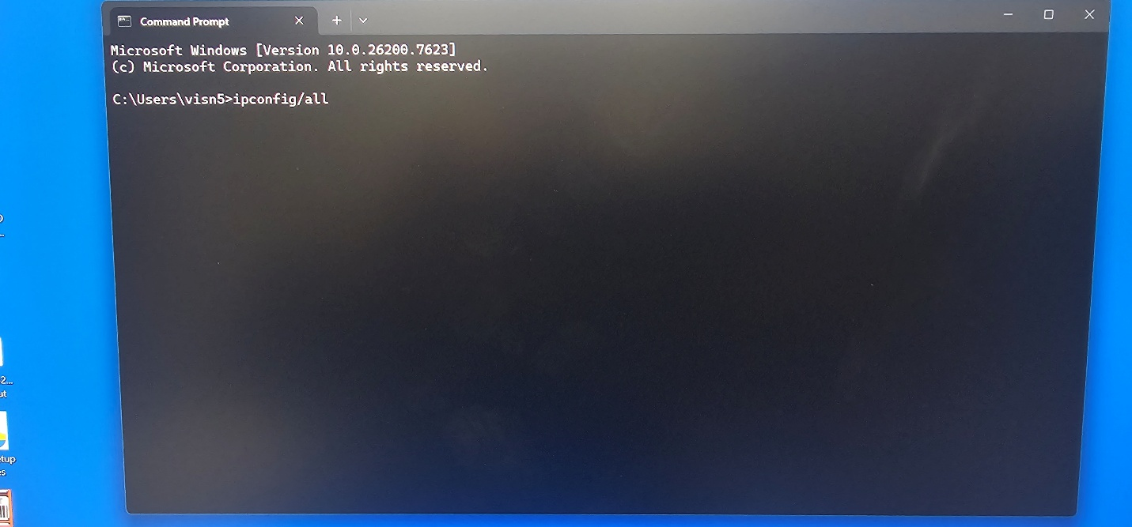

- Scroll down to “Wireless LAN adapter Wi-Fi:”
Note the IPv4 Address. Copy to Notepad, you will need this for step 7 below.
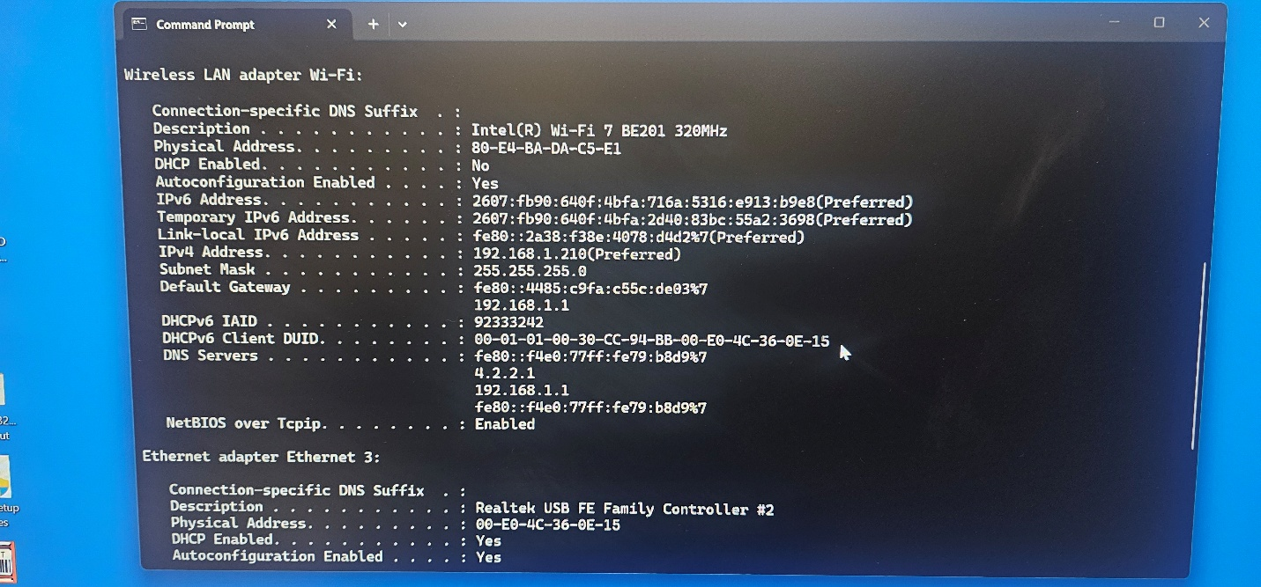

7. Open the AssetWorx! VA application. The icon looks like this example.
Click GET STARTED
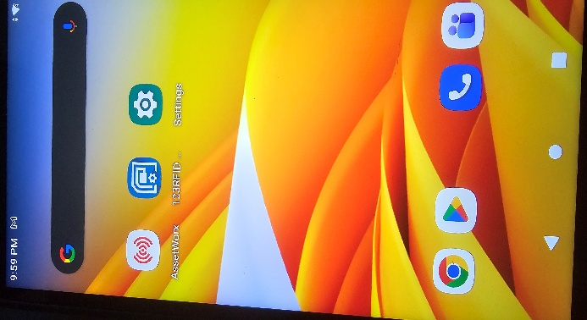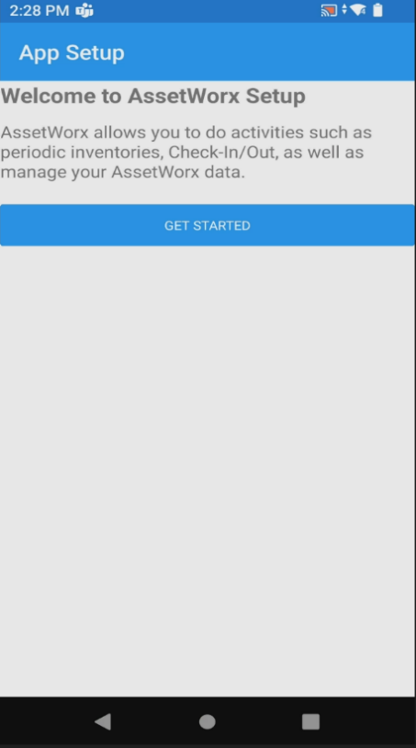

Select Web Services, Click on InApp then select Browser
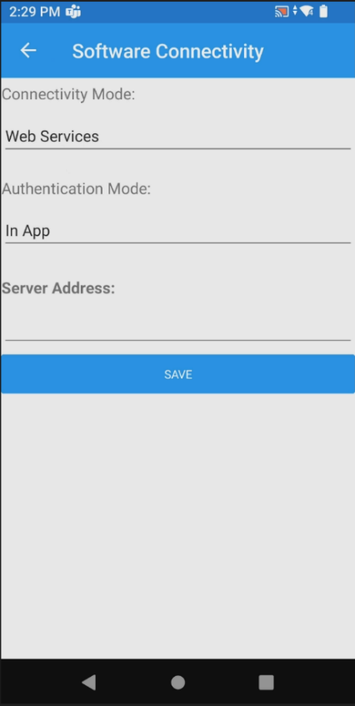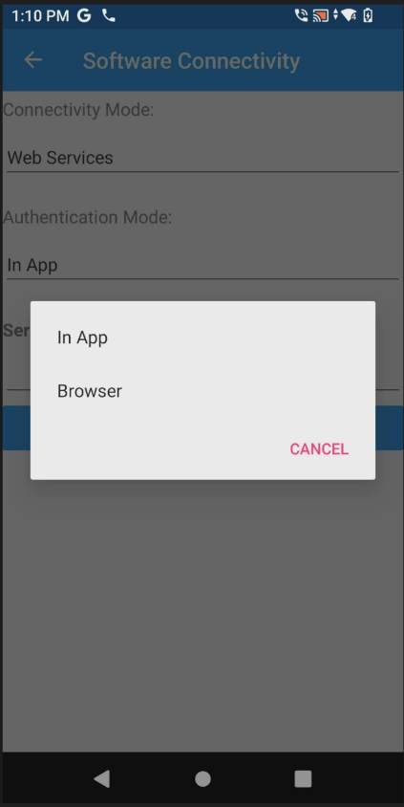

8. Enter the IPv4 Address under “Server Address:”, from Step 4, starting your sequence with “http://” followed by the IPv4 Address. For example: http://172.20.0.42 as seen in the picture below. Click Save.
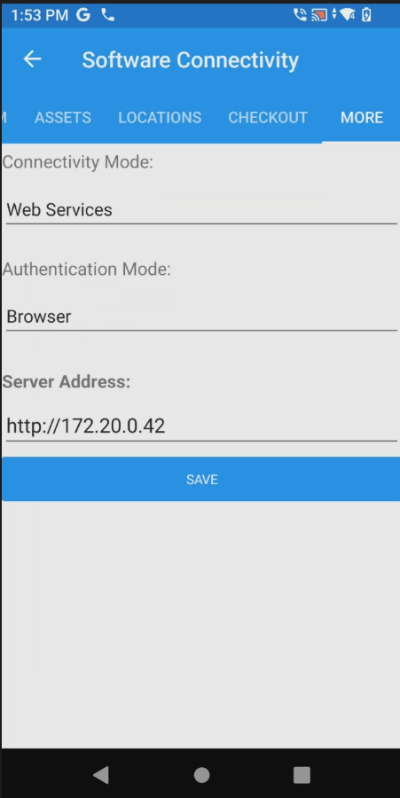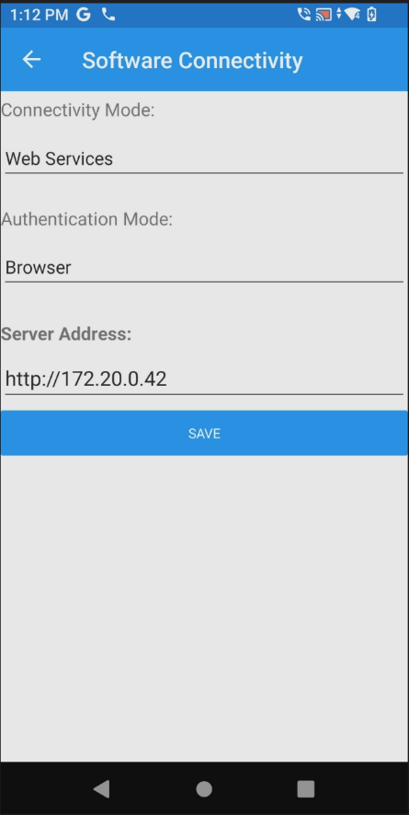
IP Address shown is only an example

- Now select “Scanner Type:”, click under “Scanner Type:”, and select option “Zebra Sled”

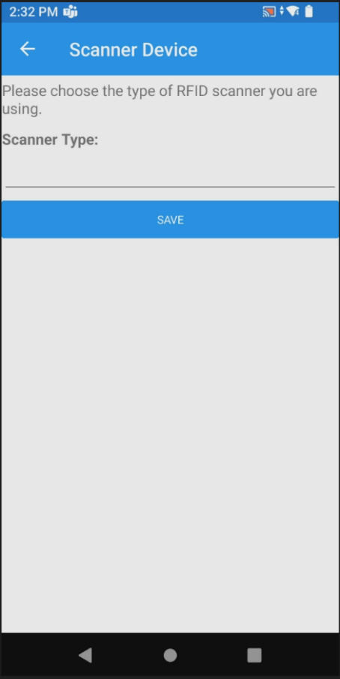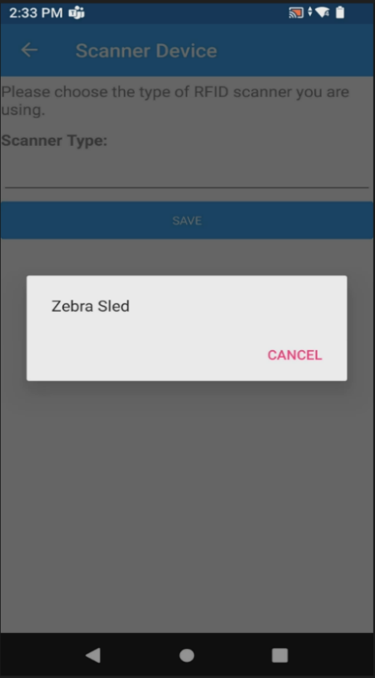

- Click “SAVE”
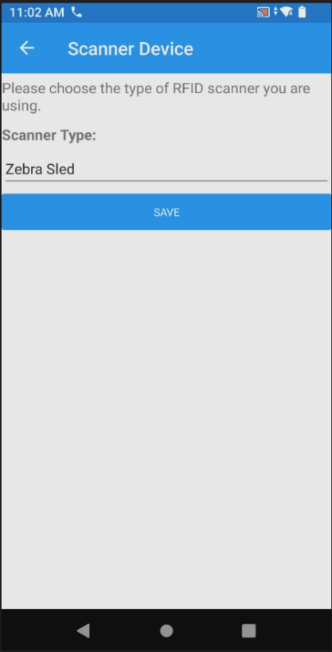

13. When prompted to sign in, username and password are: (Username: Site #, Password: Site #). Type them in each box and click “Login.”
In this example, the Site # is 512, so the Username and Password are both 512.
Baltimore will use 512a for admin user and password.

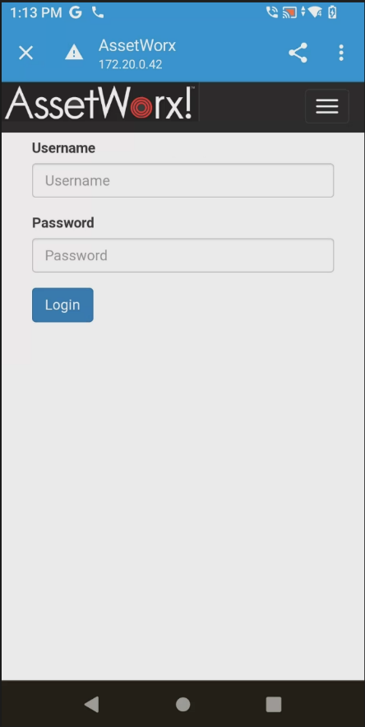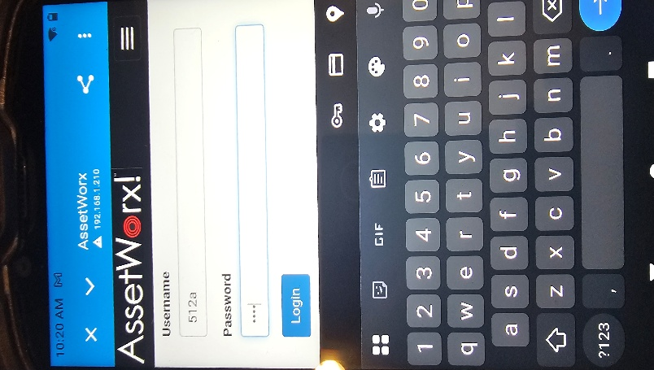
14. When “Access Location?” pops up, click “YES”, then click “ALLOW”
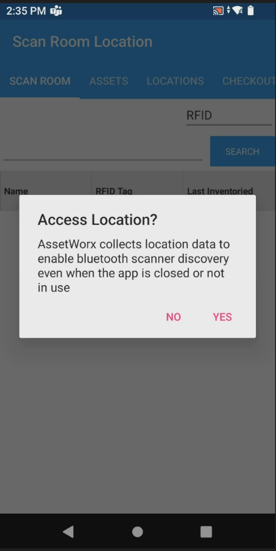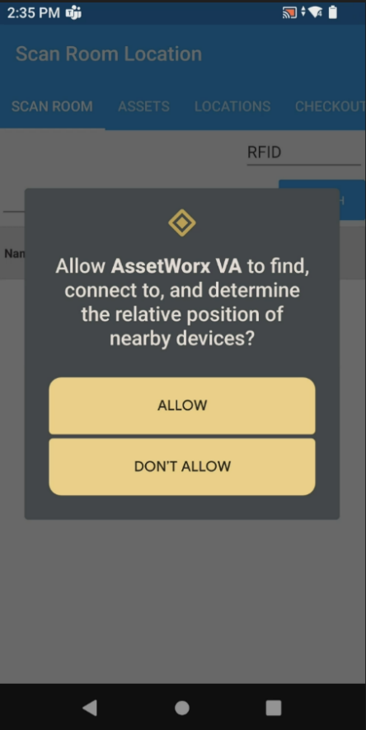

- The RFID reader is now ready to use. Scroll to “SCAN ROOM” and begin your inventory. Use the bottom trigger on the RFID reader to scan the linear location label, then use the top trigger on the RFID reader to RFID read the room. Alternatively, you may just continue to barcode scan.
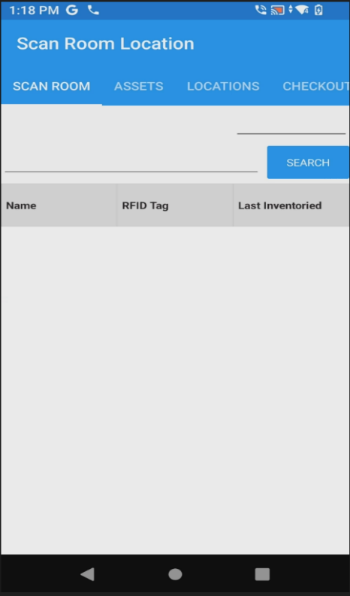

V. How to use Batch Mode Scanning
Batch Mode Scanning is used when you are visiting and doing Inventory/locates of assets where you will have no internet connection to the server.
- In AssetWorx, select “More”. Choose "Software Connectivity”, and tap where it says “Web Services”

Select More Select Connectivity Mode
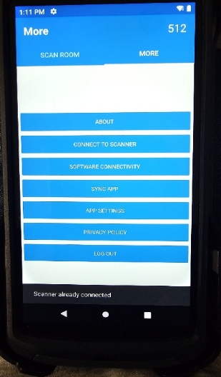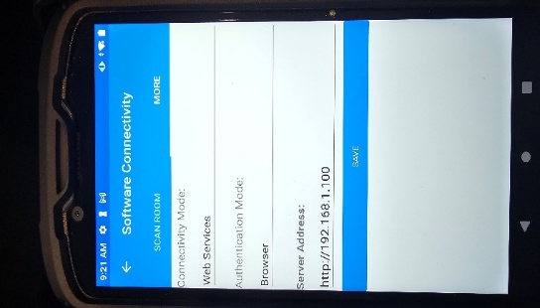

Select Batch Mode Select Save
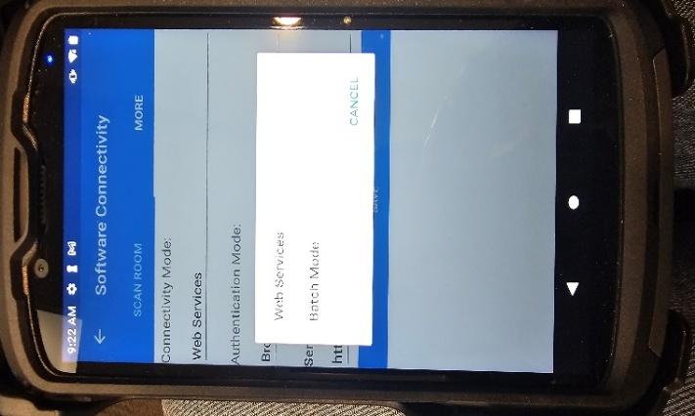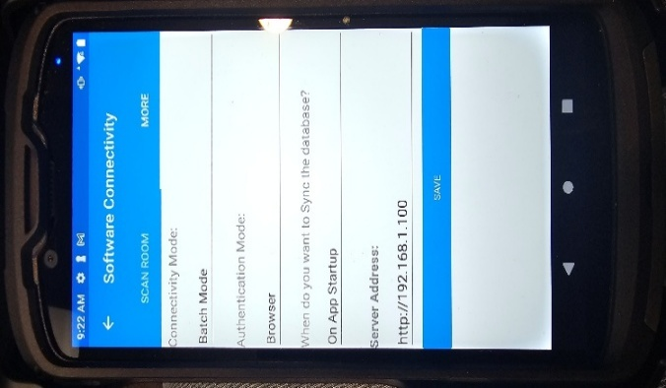
When prompted select “Yes” to sync with master database. This step will download your entire location and asset inventory from the server.

** If you are not prompted to Sync with the master database – proceed to the “Sync with the master database” section. It is important to do a sync app before, and immediately after your procedure so your data collected is retained.

Select Yes for Sync Login
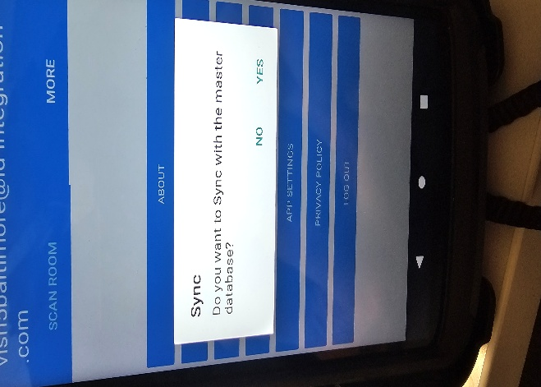
** Make sure you are near the print station when performing these actions.

- When prompted, enter your username and password.
Select Login
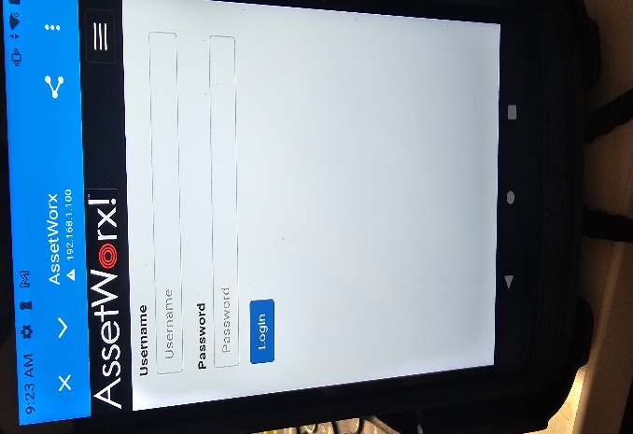
App will Sync
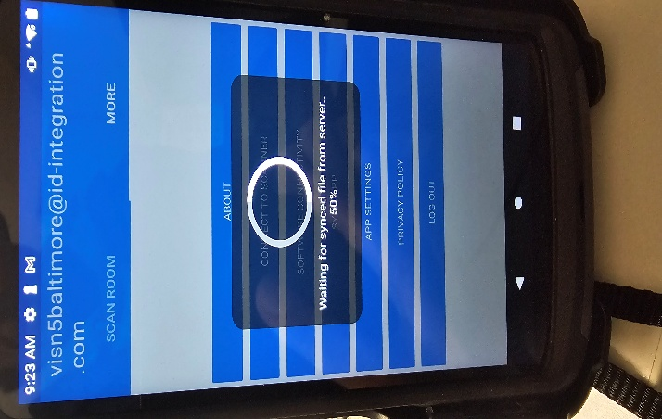

- You are now ready to inventory locations.
Scan location tag, using bottom trigger for Assets assigned to location will load. Location to be inventoried.
Use bottom trigger to scan location tag.
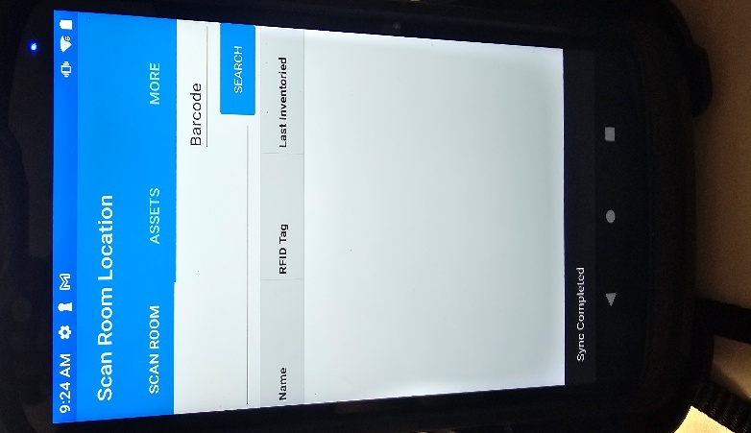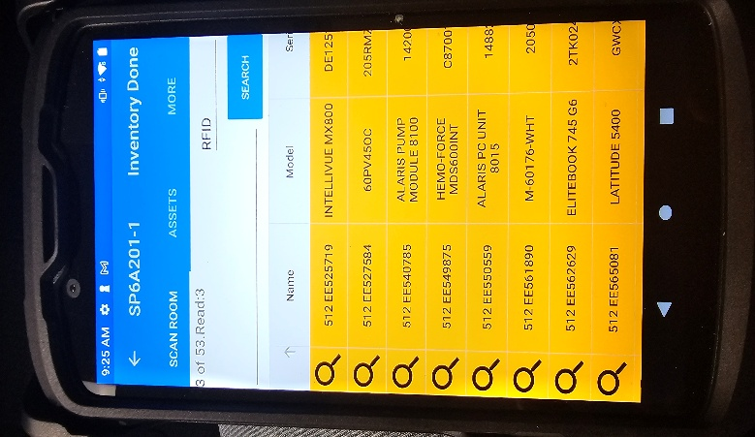

Scan Room Assets by squeezing the top trigger of the Zebra Sled and moving the reader next to all the assets in the location. You will hear beeping when an asset label has been read by the reader.
*It is worth noting that you do not have to use the top trigger for RFID reading. If preferred, you may keep scanning using bottom trigger for Barcode mode. Just start scanning barcodes on the labels.

When scanning is complete you will see assets on the screen change status to Green, Orange, Blue, or Pink. Each color represents the following:
- Orange: Item is expected in location but not found or scanned yet. You may choose to keep looking or just ignore them.
- Green: Asset was expected after scanning location label and found when scanning.
- Blue: Item was found by scanning, but not expected in this location. You can choose to ignore or move this item to the current location by clicking on the item.
- Pink: Ignore these items. They are not your assets. They are likely RFID shipping labels, or other RFID items that are not your assets.

Click on Arrow to change asset order Scroll up until Scanned assets appear
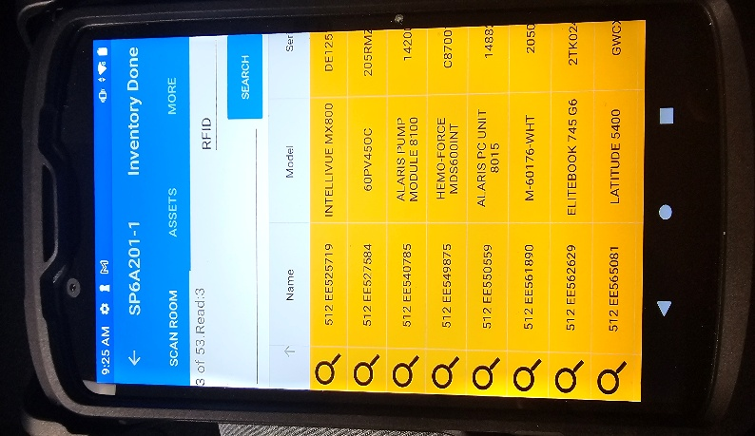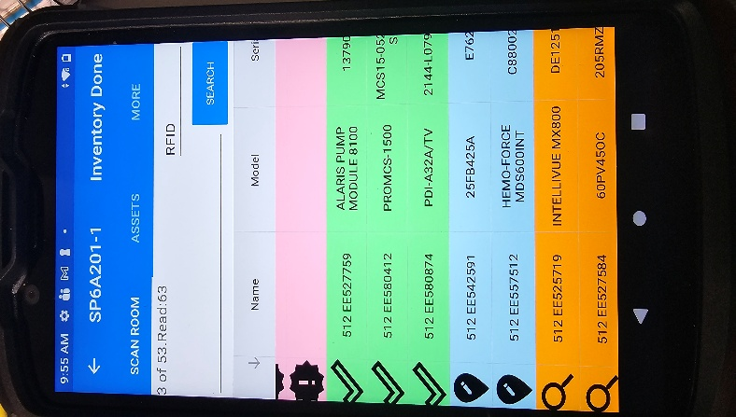

- At this time the user can select update locations for Blue assets, ignore them or locate asset (“locate” can be used for any asset regardless of color). Blue Assets are assets scanned that are NOT assigned to scanned location. Green assets are scanned assets that are assigned to scanned location.
- Move all Unexpected will reassign “ALL” blue assets to scanned location. Move from SPXXXX will move selected asset to scanned location.

Click on Blue asset Select action needed
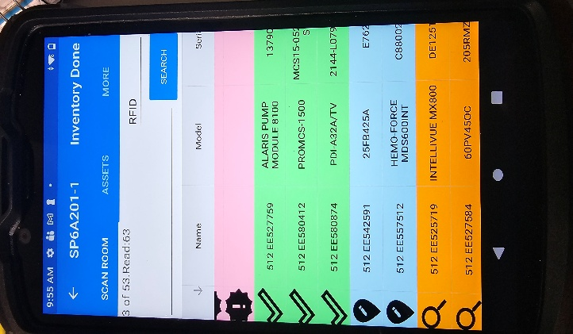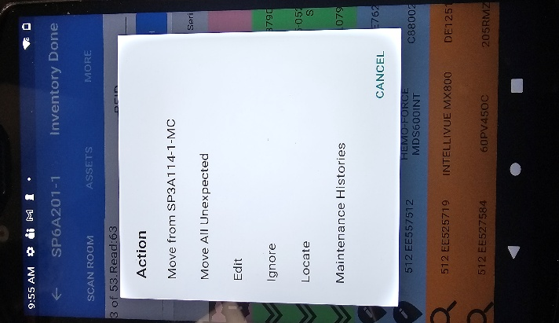

Select Inventory Done when finished scanning location
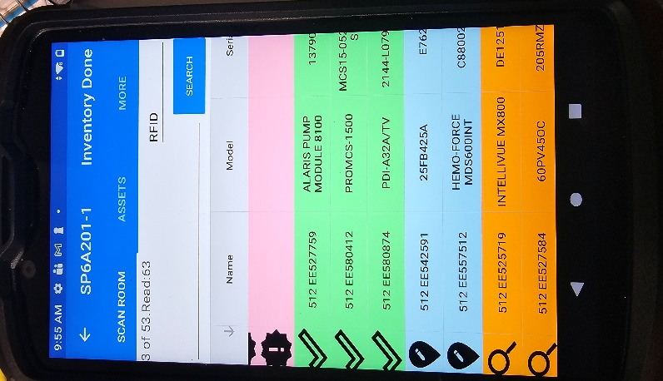

- “INVENTORY DONE” is your SAVE button and is in the upper right corner of the application.

- *Clicking INVENTORY DONE will save your scanned location and give you a fresh sheet on “SCAN ROOM” to continue to scan another location.

Proceed to scan another location if desired. To do so, repeat the steps above, starting with “Scan Room Home” and squeezing the bottom trigger of the Zebra Sled to scan the next location tag.

- At this time you can move on to next location and continue scanning as above. When scanning is completed, return to Print Cart PC.

Select More Select Sync App
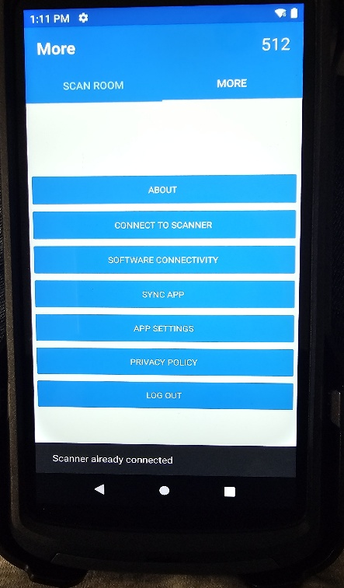

- Once you are done inventorying all locations, you are ready to create your ENNX report. Go to ENNX Documentation for instructions.

VI. How to Use “Locate” Feature on Zebra Sled Reader
Locate Single Item
- Open the AssetWorx application on the Zebra Sled Reader. Click on “ASSETS”.
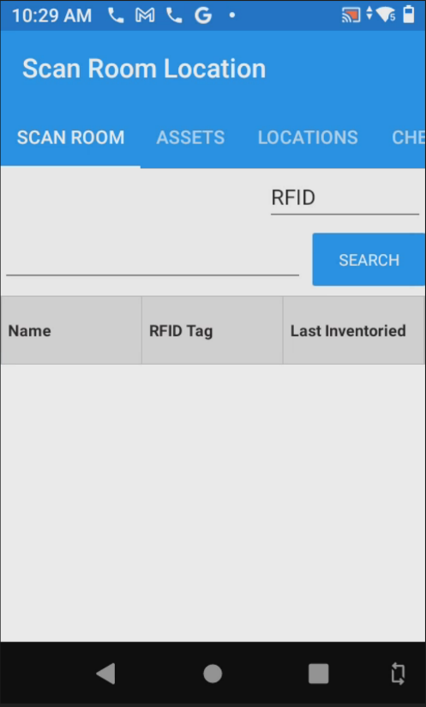
- Enter your EE # as shown, starting with your site number. See picture for reference.
- Click “Search” and the Asset will populate. Tap on it and select “Locate”.
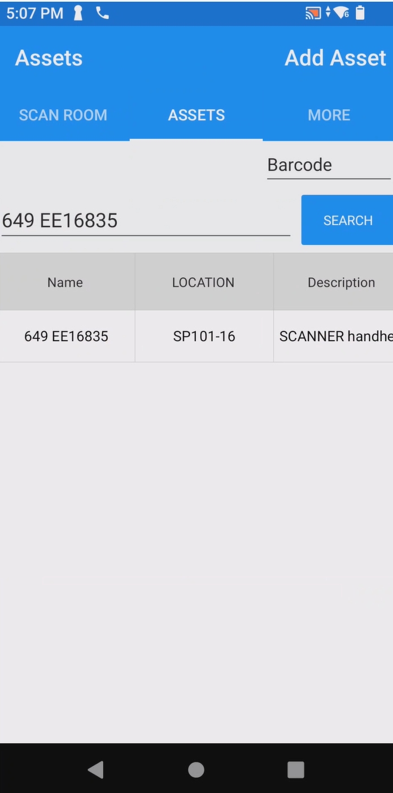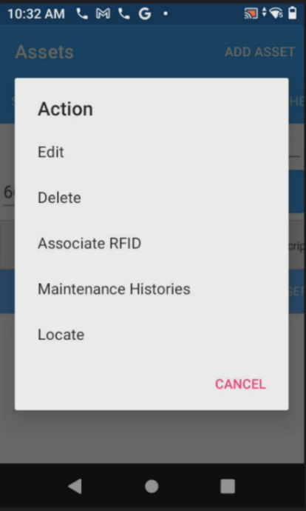

- Hold down the top trigger on Zebra Sled RFID reader. As you get closer to the item you are looking for the reader will start filling up a blue line below “Strength”. You will also hear a beeping sound. As you get closer the beeping will become higher pitched.

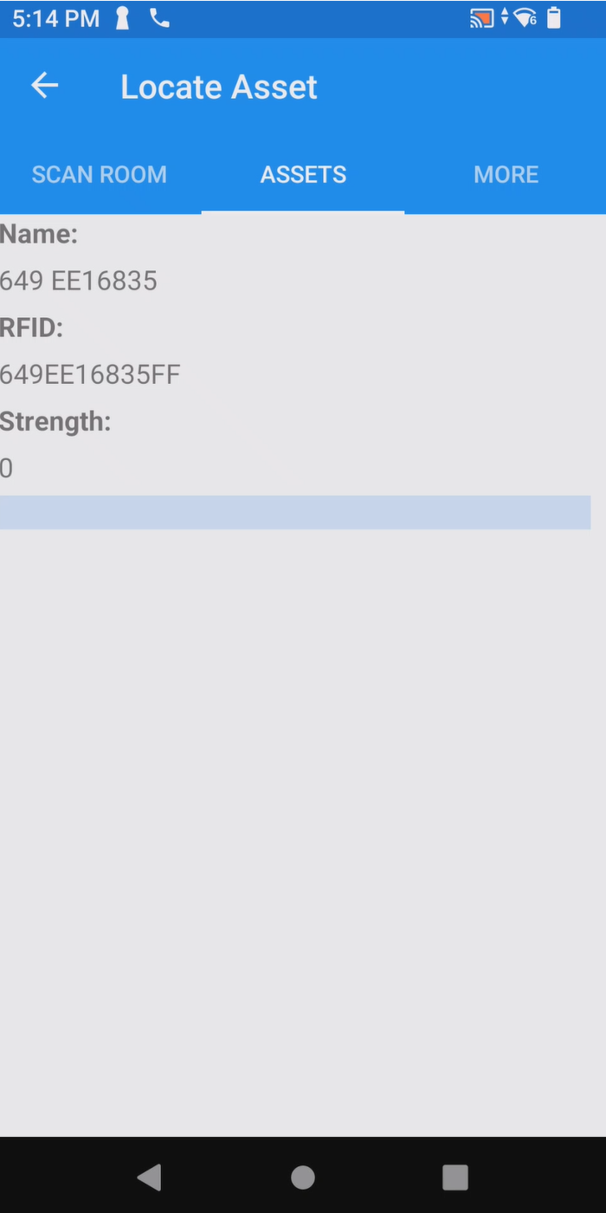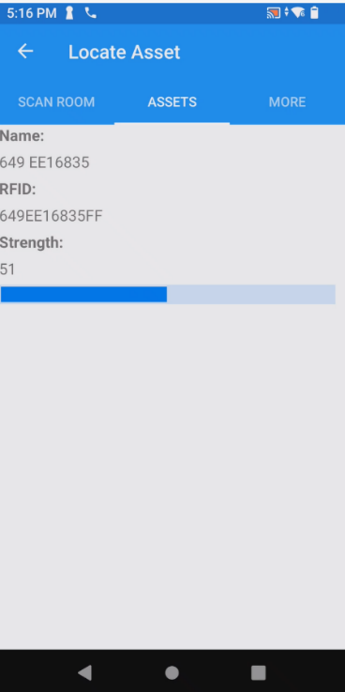
Locate a Single Item after Scanning Location
Another way to locate an item is by tapping it during an inventory of a room. In situations where you find items that you do not expect to find and display in Blue, follow these steps to locate those items.
- Squeeze the bottom trigger of the RFID reader and scan the linear location tag.
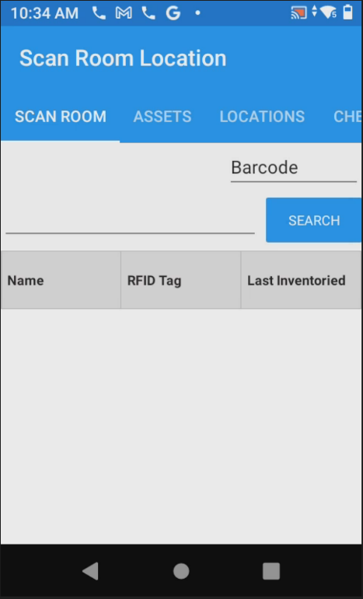
- Squeeze the top trigger of the reader and perform an inventory of the room. When complete, tap the box near “Name” as shown in the picture to re-organize the assets you scanned.
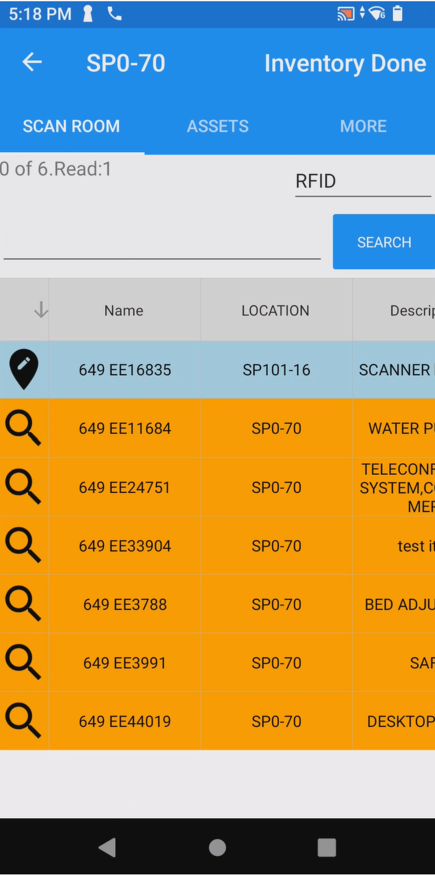
Re-organize your assets by tapping here. This will show the Green, expected, and Blue, not expected, items that you scanned. You can now locate items you have discovered in your location.

- After reading and scanning your location, click on the item you would like to locate and tap “Locate”.
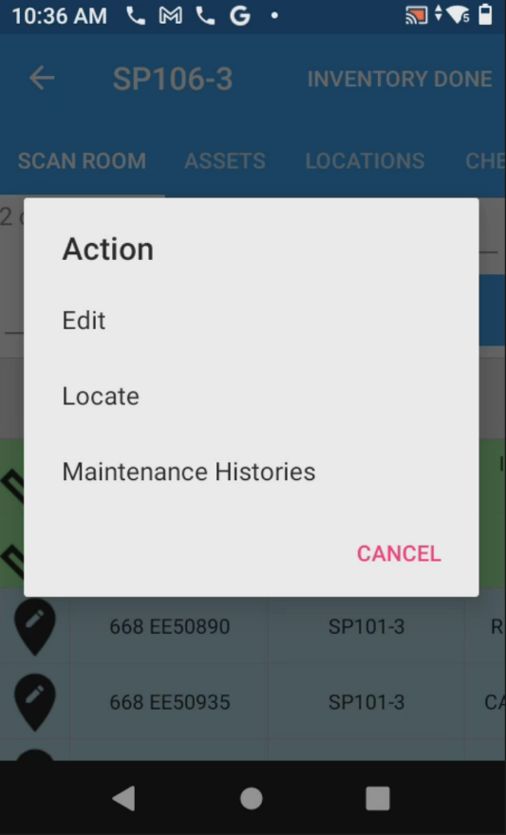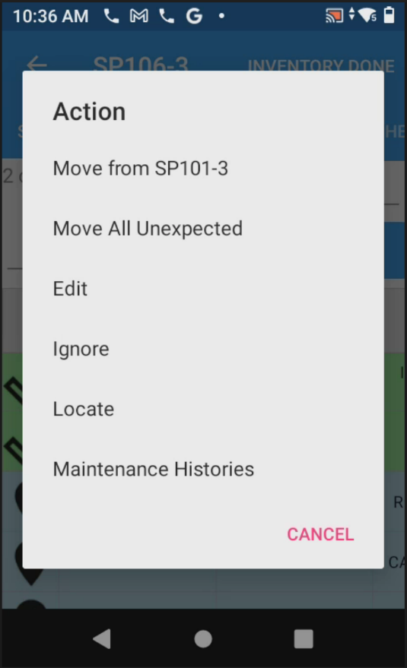
When you tap on an asset that is Blue, it will look like this. Tap “Locate”
Example of selecting a “Green” expected item found. Choose “Locate”

- Now squeeze the top trigger of the RFID reader. You will have a blue bar that fills up as you get
Closer to the item. You will also hear beeping and the sound will become higher pitched.
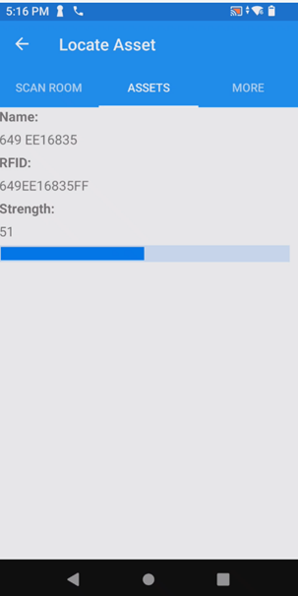

VII. How to Adjust Power on Zebra Sled Reader
- Open the AssetWorx app. This is the main screen.
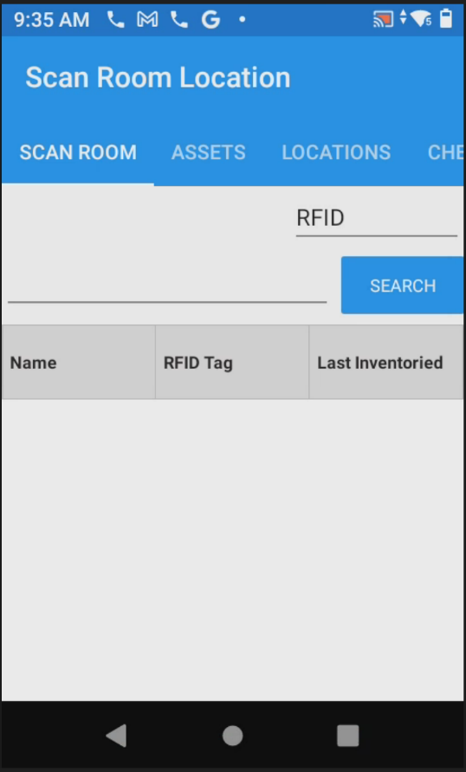
- Scroll over to “MORE”.
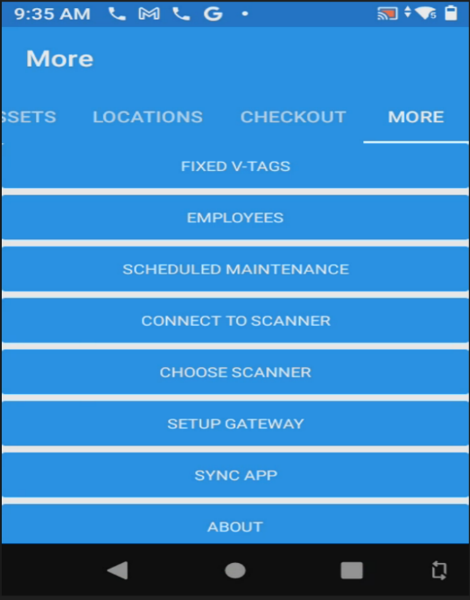

- Scroll down until you see the option “APP SETTINGS” and click on it.
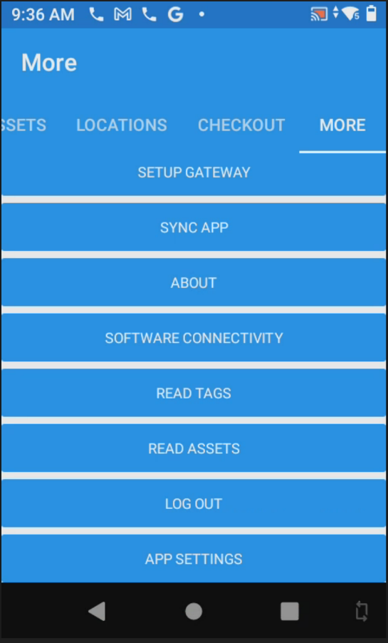
- Click on the number below, “Inventory Power Level (1-100):”, this will allow you to adjust the RFID power level on your RFID reader.
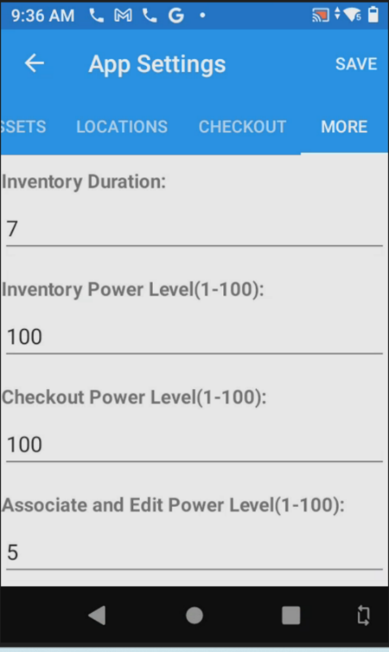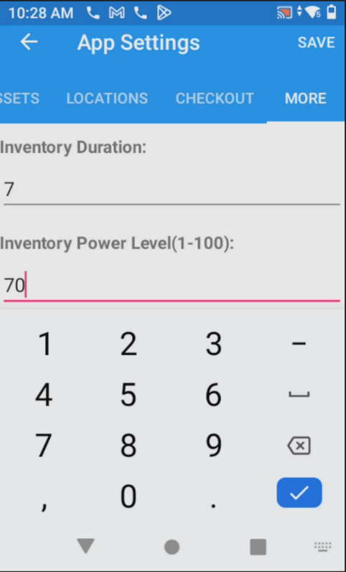
Once you click here, it will bring up a number pad and allow you to put in your desired RFID Power. 70 is recommended for areas where different locations are in close proximity to each other.

- Click “SAVE”. It will say “Settings updated”. You may continue to use the reader now.

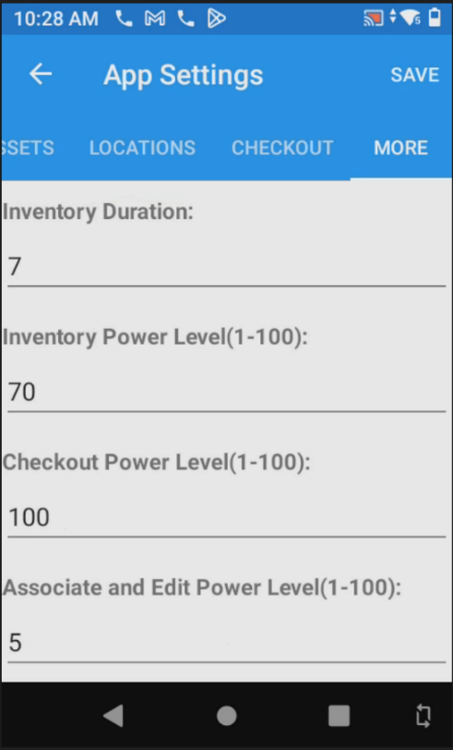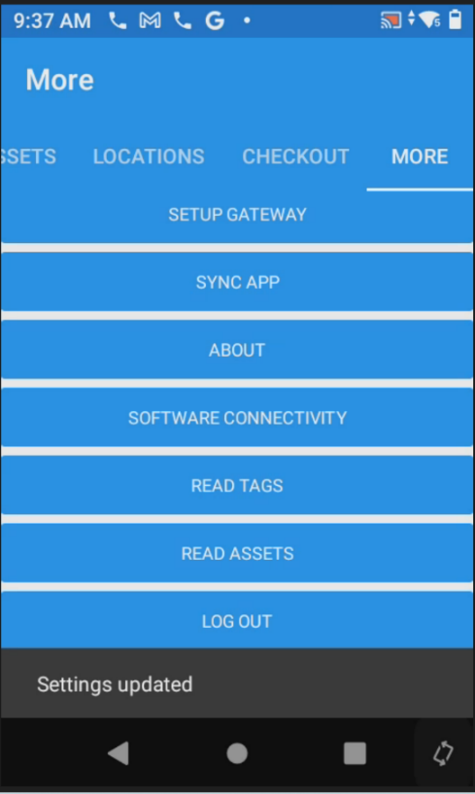

VIII. Missing Location Tag: What do I do now?
This document will help if the rooms linear barcode location tag is missing.
Our assumption here is that you have already signed in with your site # and you are now performing inventory or locating/relocating assets.
- Begin by opening AssetWorx! VA Mobile Application on the RFID Reader and scroll to “Scan Room”.

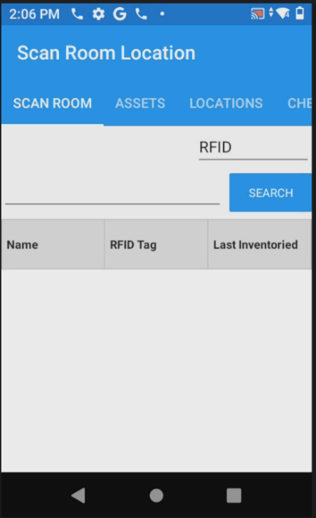

- Click to the left of the search bar to see the keyboard and type in the full location of the room.
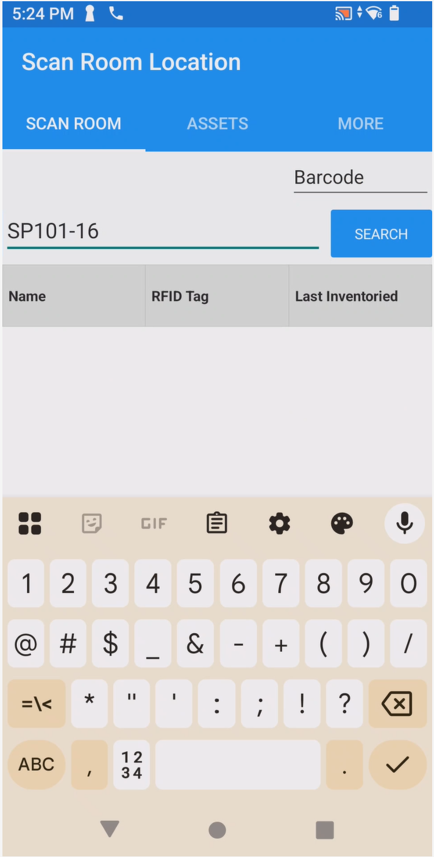
Tap here and type the location number. Then press “SEARCH”

- Location will populate as pictured below.
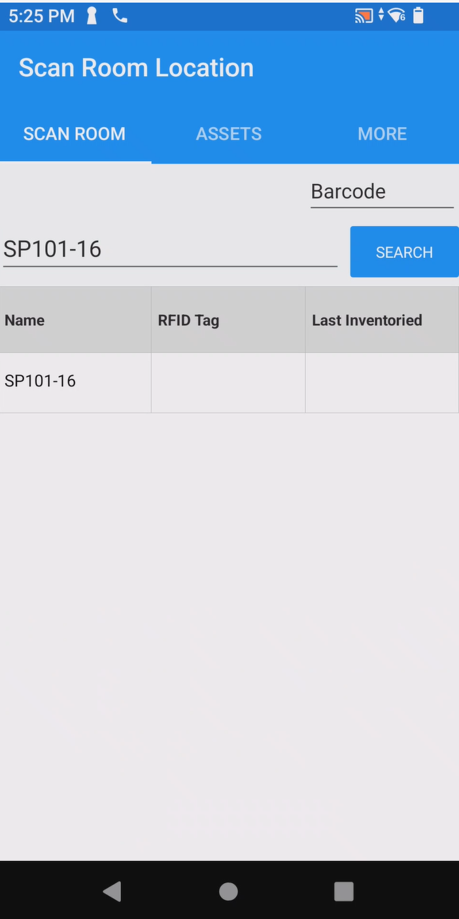
Location will populate as in this example after selecting “SEARCH”. Proceed by clicking (touching) the location.
- Items expected in this location will now populate as if you scanned the location barcode.
Application is now ready to proceed with inventory.
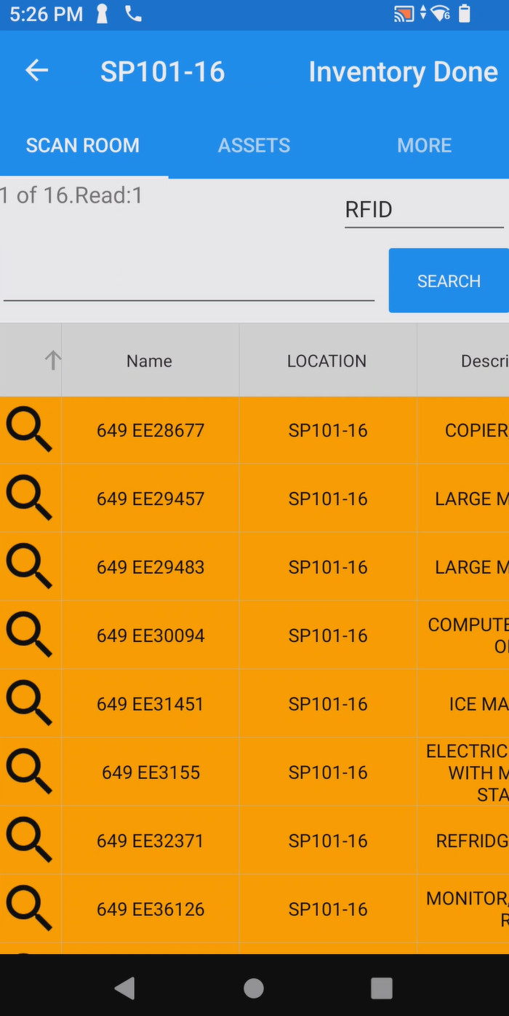
Squeeze the top trigger of the RFID Sled and proceed to scan the room.
You may also barcode scan items and alternate between methods depending on your preference.
When scanning is complete, select “INVENTORY DONE”. Proceed to perform inventory at other locations as needed.
****If there is another room that does not have a linear location tag, repeat the instructions above.

IX. How to Use the Logout Feature on Zebra Sled Reader
*Using the logout feature will allow you to logout of AssetWorx and change users if necessary. Note that you will login again before using the reader for inventory.
- Open the AssetWorx app on the Zebra TC53 Sled Reader. This is the main screen.
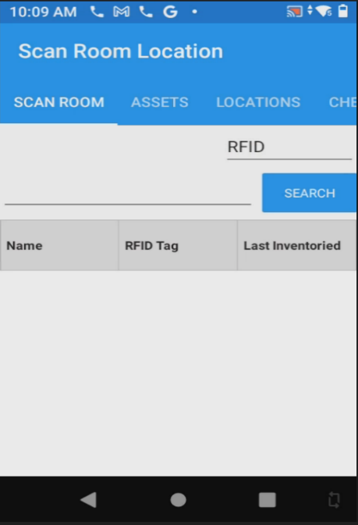

- Scroll over to “MORE”. Scroll down until you see “LOG OUT” and tap to select it.
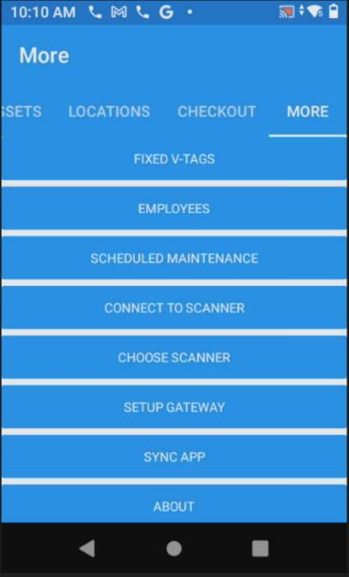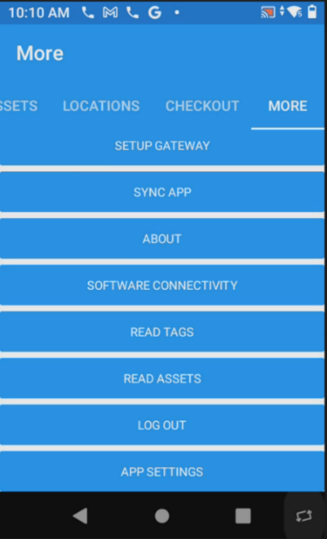

- You will be shown a screen that says “AssetWorx Initializing” wait a few seconds.
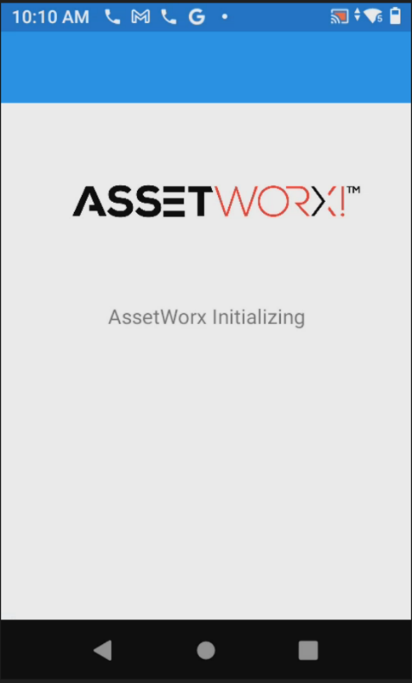

- You will be redirected to the login page of AssetWorx!. Login with Username and Password:
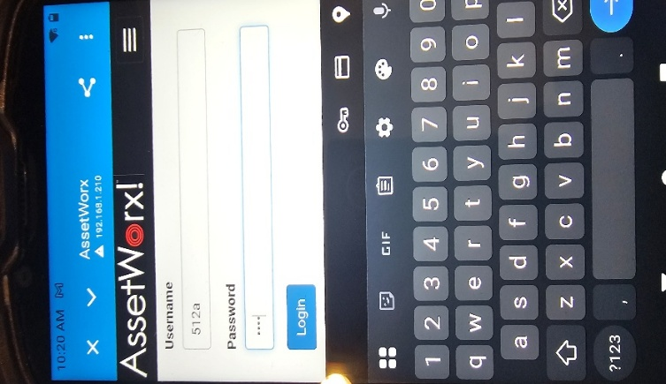

- Once you click login, you will be directed to this page. You will notice it says, “Scanner already connected”, you may now continue to inventory.

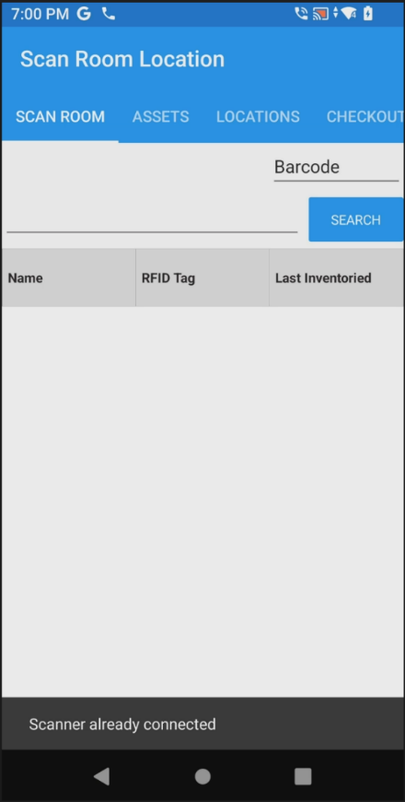

X. How to Use the ENNX Report Generator
This document will give basic settings and solutions for possible RFID Tag errors on the Zebra ZT441R and ZD621R RFID printers.
- Preliminary Settings
    - Screen Calibration
    - Printer Settings
    - Wizards
- Media
- Media Install
- Media Adjustments
- Tear Off Setting
- Gap Sensor Adjustment
- Media Calibrate
- RFID Calibrate
- Image Adjustments
- Vertical Adjustment
- Horizontal Adjustment
- Printing Errors
- Voids
- Not Printing
- Media Out

XI. Summary:
This guide is a subset of the full AssetWorx Dashboard Guide – focusing specifically on the Generation of VA ENNX Report Data. This tool mimics the original AEMS/MERS handheld scanner output, allowing users to generate and export ENNX text reports that can be imported into the AEMS/MERS interface.
The inventory data show has been previously uploaded using the AssetWorx app on the mobile Zebra RFID readers. This browser tool filters that inventory data by date, date range, user, and/or status code. And produces ENNX report data which can export via simply Cut & Paste, Downloaded Text File, or auto emailed to one or more recipients.

XII. ENNX Report:

Follow the steps below to use this tool.

Open and Login to the ENNX Report tool -
The Dashboard is generally accessed by a URL shortcut placed on the User’s Desktop.
- Double-Click on the Desktop shortcut to open the Dashboard within your PC’s default browser. The page should open to the ENNX Report with the Selected Narbar option shown.
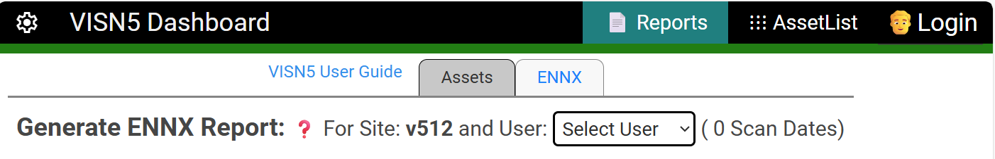
- Click the ‘Login’ link in the top navbar, to select your site. Copy and paste in the supplied password if not already entered. Click’ Log On’ to fetch your site’s AssetWorx inventory ENNX data. The upper-right corner icon of the navbar will switch from a person to your station code.

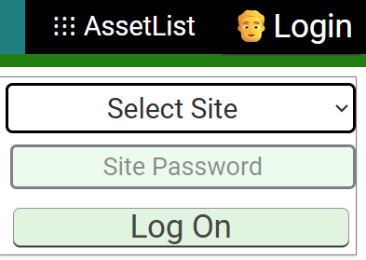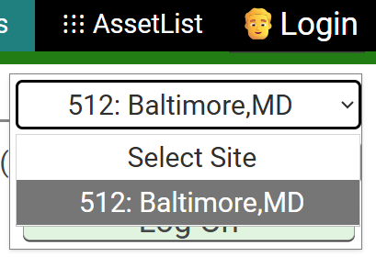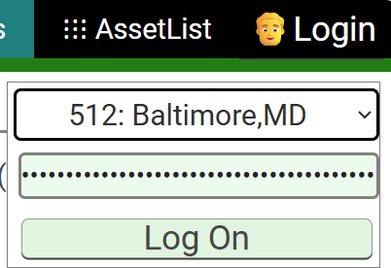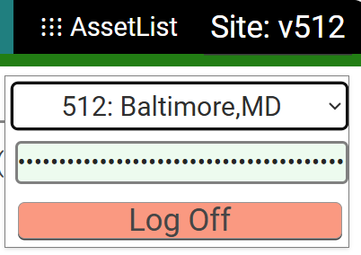
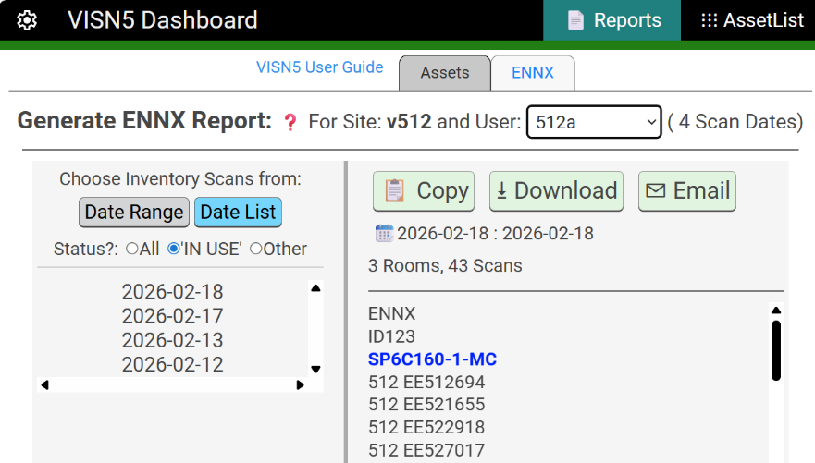
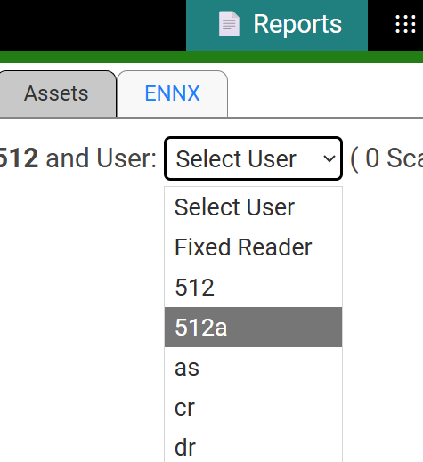
- Select the username of interest from the pull down menu. This will generate the following 2-column layout. Next to the selected username will be the total number of daily scan records that are available for that user.

- The ENNX Report is formed on the right side, with Room Location scans shown in Blue. Above the report, you will find some quick statistics about the date (or date range) which was selected on the left column. Both left and right columns include vertical scrollbars to allow visibility of longer reports.
ENNX Report Tool Features -
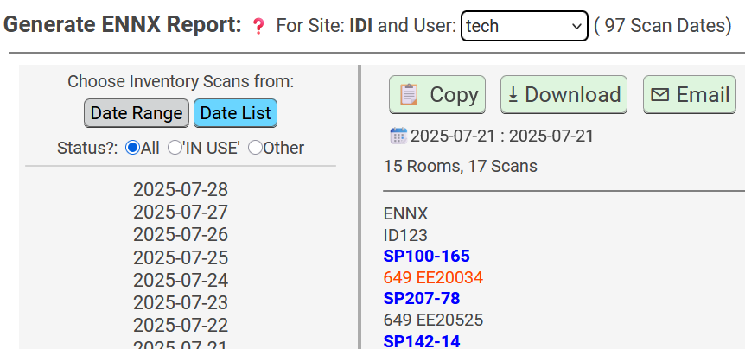
- The report will default to showing ALL inventory scans, regardless of the item’s status. If the selected scan date includes scans of assets that are currently NOT at ‘IN USE’ status, these scans will show in Red text.
The user can filter out those ‘red’ items by selecting the ‘IN USE’ radio button below the Date Range and List buttons.
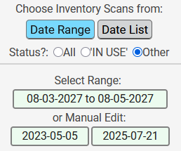
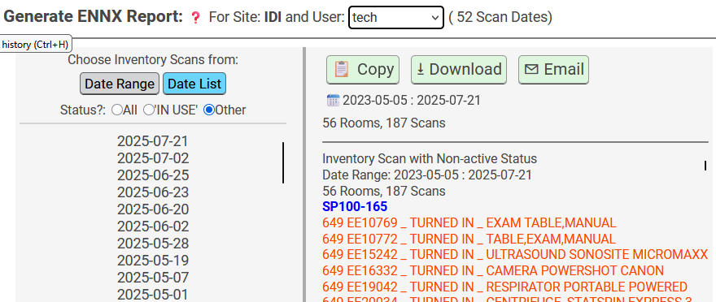
- If the user clicks the ‘Other’ radio button, the right-hand column deviates from a valid ENNX report and shows a listing of all inactive scanned items along with their status codes and item descriptions.
- Date Ranges can also be specified, in order to group multiple daily reports into a single ENNX file to upload to AEMS/MERS. Date Range selection can either be accomplished with a calendar tool, or by manual edit of a start and end date range.

Exporting ENNX Reports -
- Any of the ENNX reports, whether for a single date or date range can be exported in 3 separate ways, at the user’s preference.
  - Click the Copy button to perform a simple Windows Clipboard ‘Copy’, allowing you to ‘Paste’ the ENNX report data into any other software field that you wish.
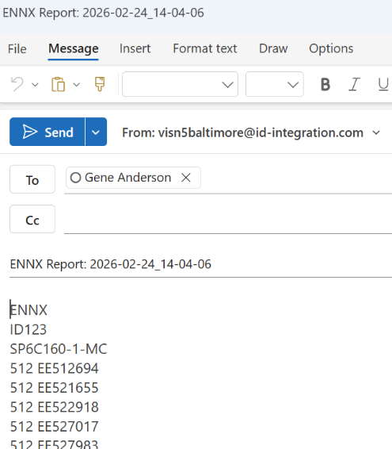
  - Click the Download button to create a text file with the ENNX report in your local PC’s Downloads folder. The filenames include date/timestamps so that it’s impossible to overwrite previous files.
  - Click the Email button to auto-start your PC’s default email tool (Outlook or other). An email will be auto generated with To: , Subject: , and the ENNX report pasted into the Body of the email. The email To: field is defined in the Dashboard tool’s setup ‘gear’ located at the left end of the top navigation bar. You can include multiple email addresses there – separated by semicolons.
  - Copy button: clipboard copy to ‘Cut&Paste’ in any program.
  - Dowload button: creates unique filename with date/timestamp on the local PC.
  - Email button: launches the users default email program and auto creates the To, Subject, and Body fields using the To field in the Dashboard Settings ‘Gear’ menu.

Configuring ENNX Reports -
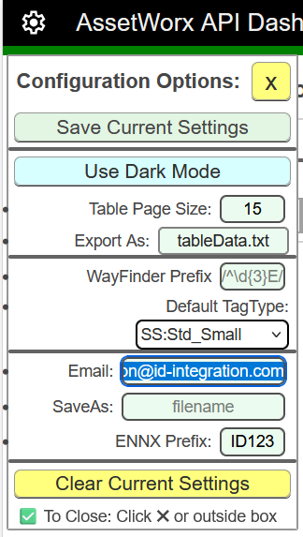
There is really nothing to configure with the ENNX Reports except for the Email To: listings. One can edit this email field via the Dashboard’s ‘Gear’ Icon in the upper left corner of the top navigation bar.
The user can add one of more email addresses to the blue highlighted field to the left. If using more than one email, you must separate with a semicolon. When done, click the ‘Save Current Settings’ button at the top of the Configuration Options form.
The ENNX page will now be configured for your own personal settings, and those settings will be stored under your user browser profile. If more than one user shares a PC, but has a separate Windows login account, each user can have their own setting preferences.

XIII. Basic Settings for RFID Printers
- Use the following settings when first setting up printers. These are the baseline settings that will work for most tag applications.

First, on the printer screen, select MENU then Settings. Select the following settings:
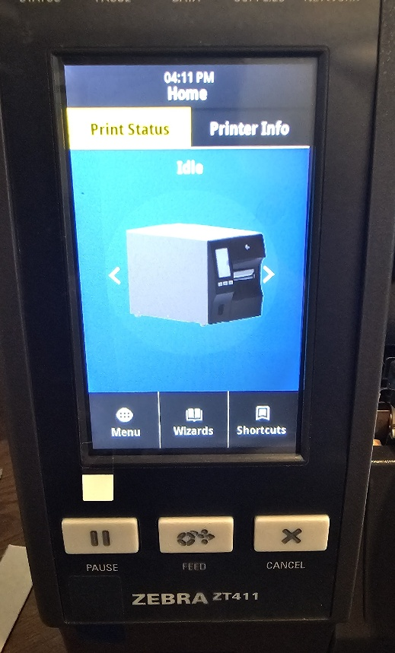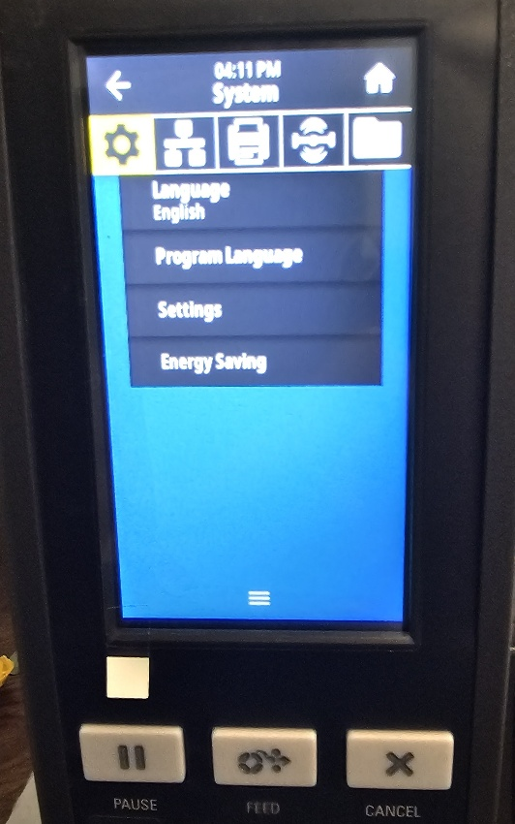

Select Screen Calibration and follow steps. Try to be precise when touching
the five points.
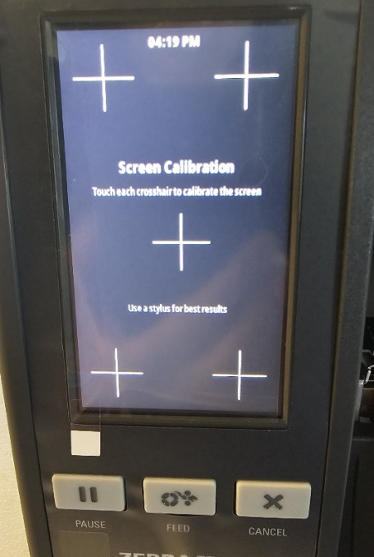
If needed adjust Time Format and Date and Time.
Select the following settings:
Password Level: None
Power Up Action: No Motion
Head Close Action: Calibrate (This can be changed to None at any time)
Next, select Printer Icon/Print Quality and select the following Settings:
Darkness: Set Darkness to 25 for ZT411R and 20 for ZD621R
Print Speed: 4
Print Type: Thermal Transfer
Media Type: Gap/Notch
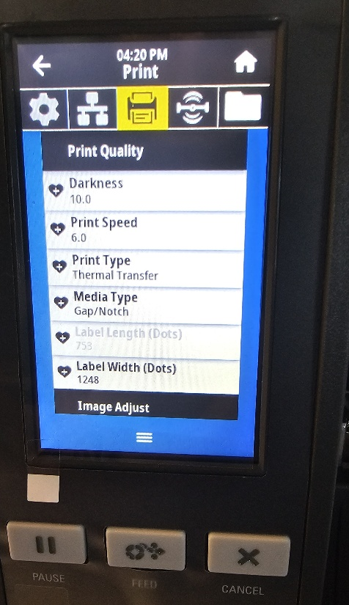

Printer/Image Adjust and select the following Settings:
Media Handling: Tear Off
Rotate Label: 0
Backfeed: N
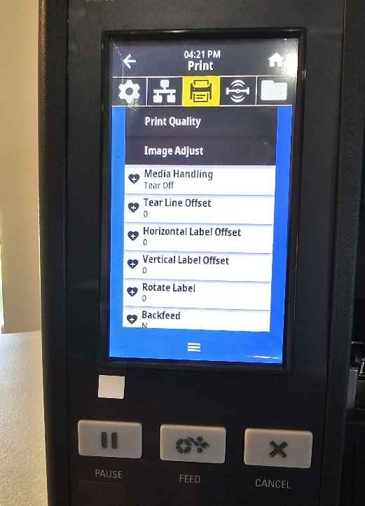
Media Installation

Both printers have media installation instructions that can be seen when printers doors are opened.
ZD621
First, install the print ribbon by installing the small cardboard tube on the top. Make sure notch in gear on left is aligned with cut out on cardboard tube.

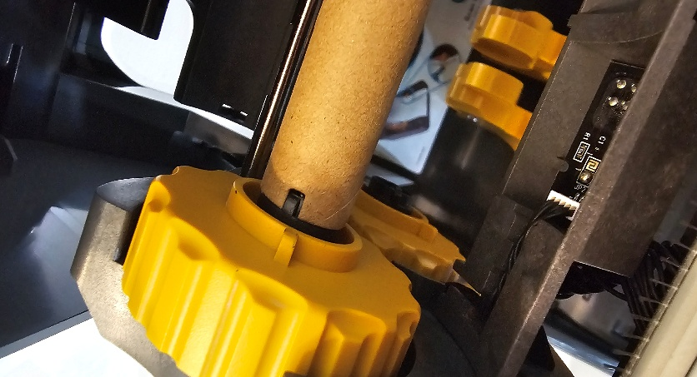
Open ribbon and install on back tube and pull ribbon to front of printer and wrap to top front tube. Wrap ribbon around tube several time until tight and not slipping. Make sure ribbon stays aligned with rear tube.
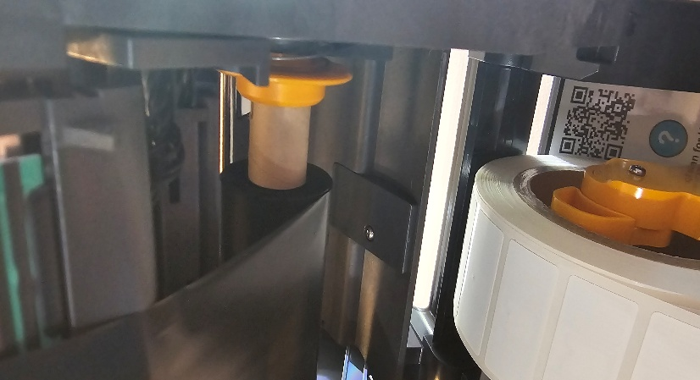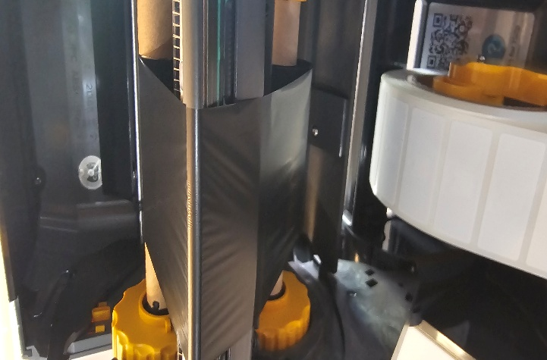
Next, load media. Load media so as labels are facing up. On front is the Gap Sensor, make sure this is centered on label. THIS MAY NEED TO BE ADJUSTED LEFT OR RIGHT For Flag Tag Material. Slide label material towards front and under alignment notches. Make sure at least one label is outside of printer and close top.
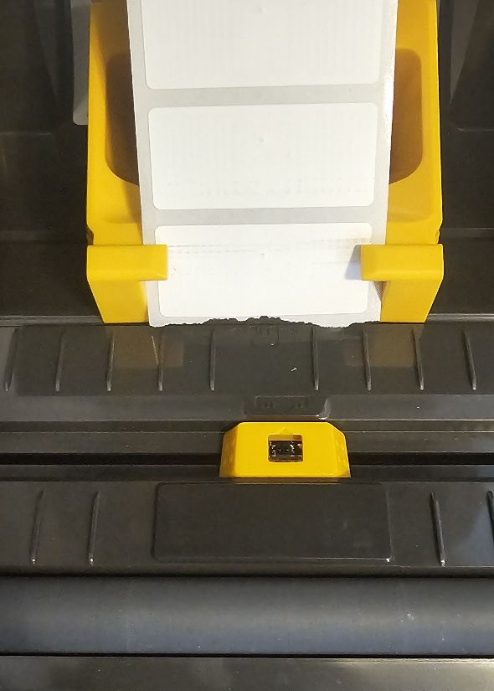
At this point Media will Auto Calibrate.
If Auto Media Calibrate Fails proceed to Manual Media Calibrate and follow onscreen instructions.
ZT411
First, install the print ribbon. Release the print head by pulling release lever to the rear.

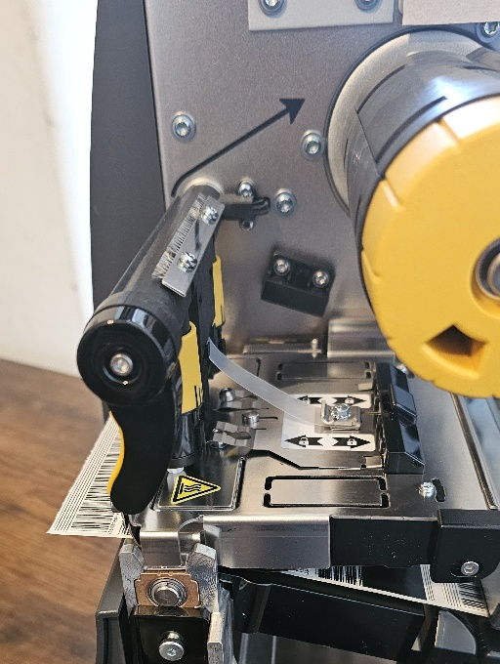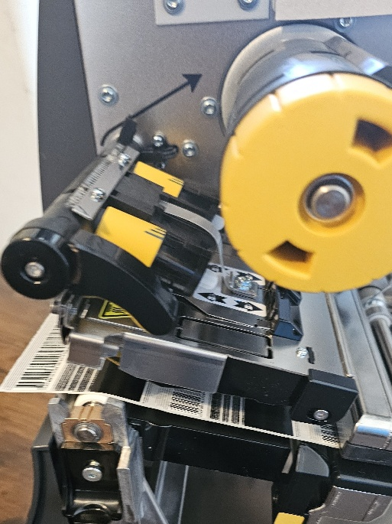
Open roll of print ribbon and slide onto top back roller.
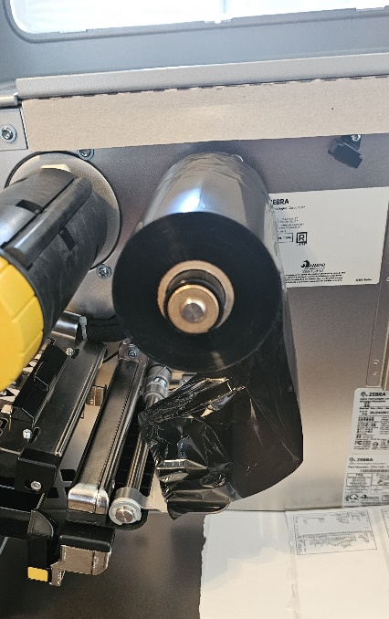

Slide ribbon under print head and over front top roller.
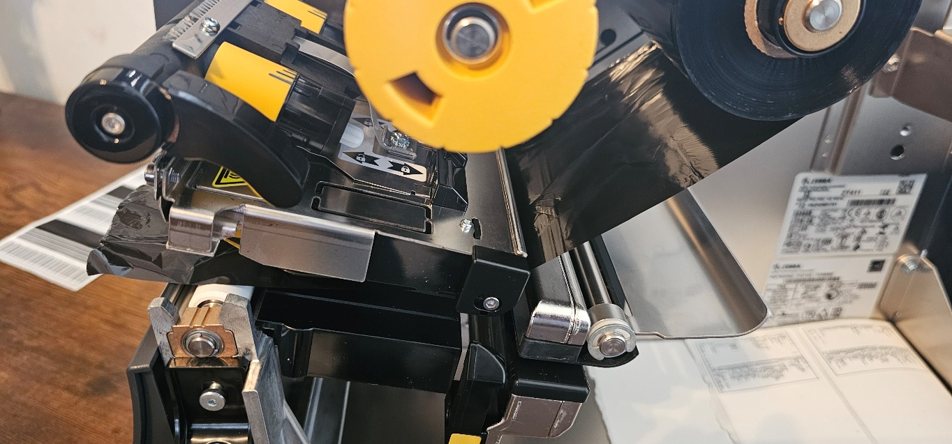
Wrap ribbon around top middle roller several times by turning roller until ribbon no longer slips. Make sure ribbon stays aligned with rear ribbon roll.
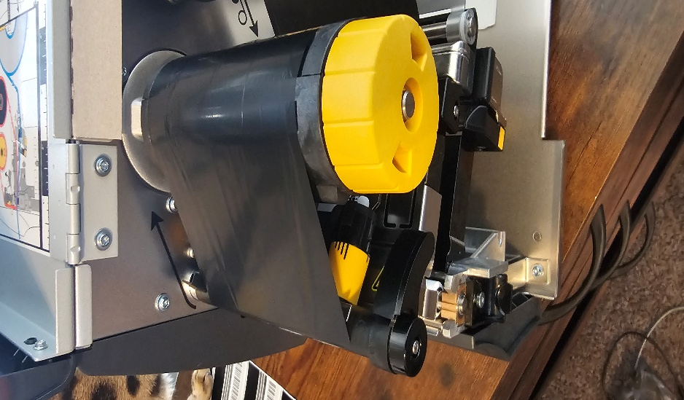
Next, install media, label up, onto lower metal rail. Slide all the way back. Slide peg up against media roll.
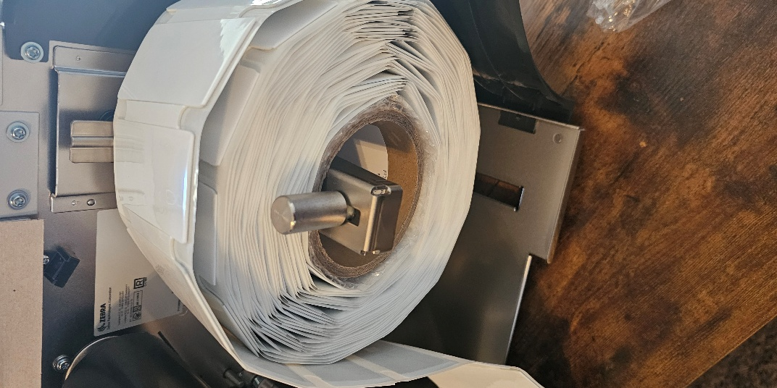
Pull media forward and under guide rail and under print head.
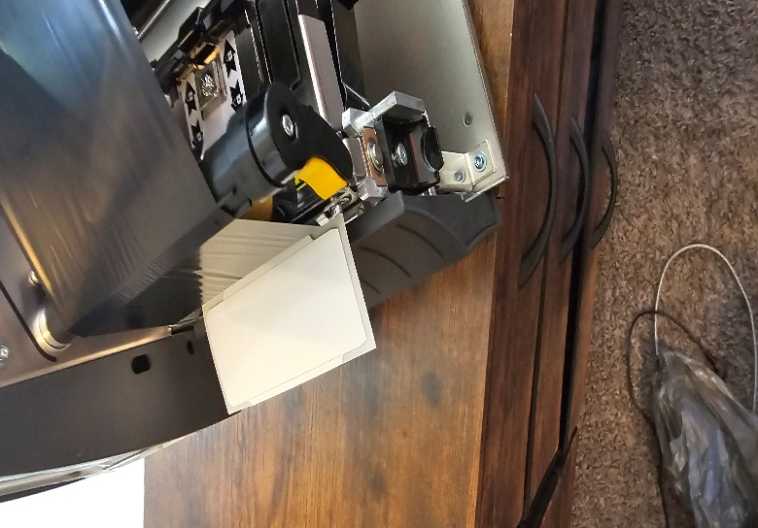
Forward of and under guide rail, adjust gap sensor by sliding left or right and line sensor up with gap between labels as shown below.
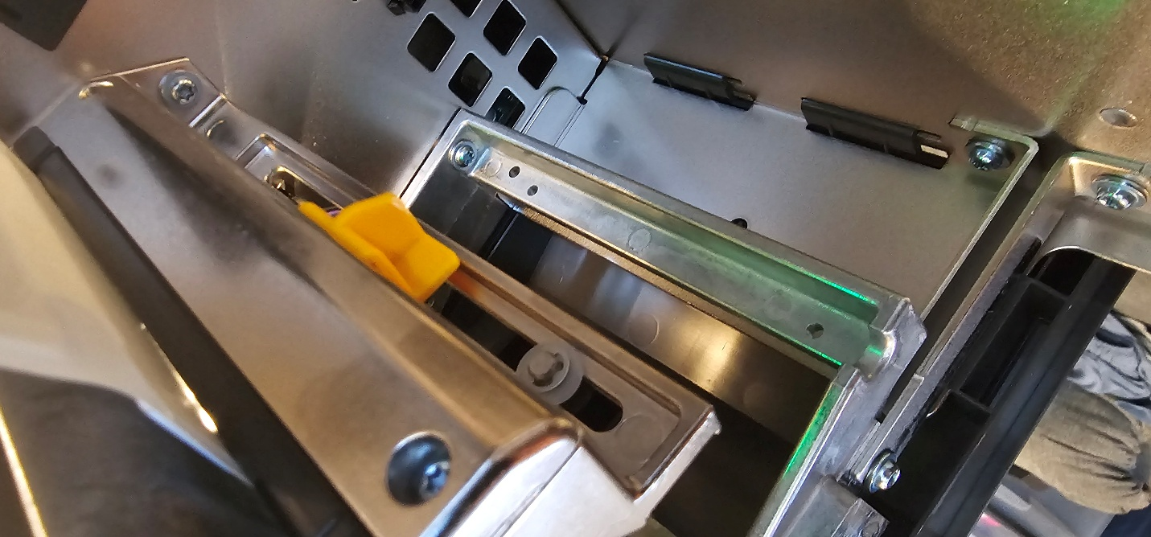

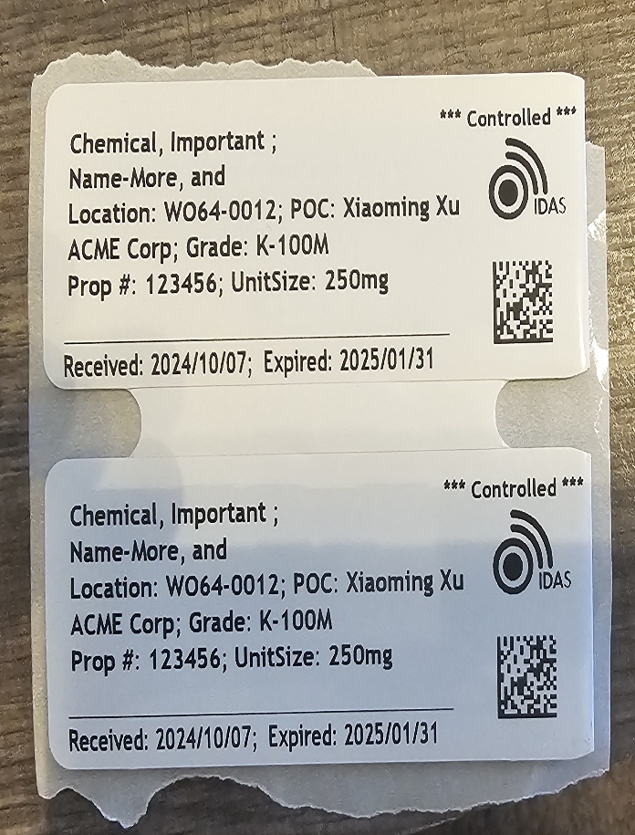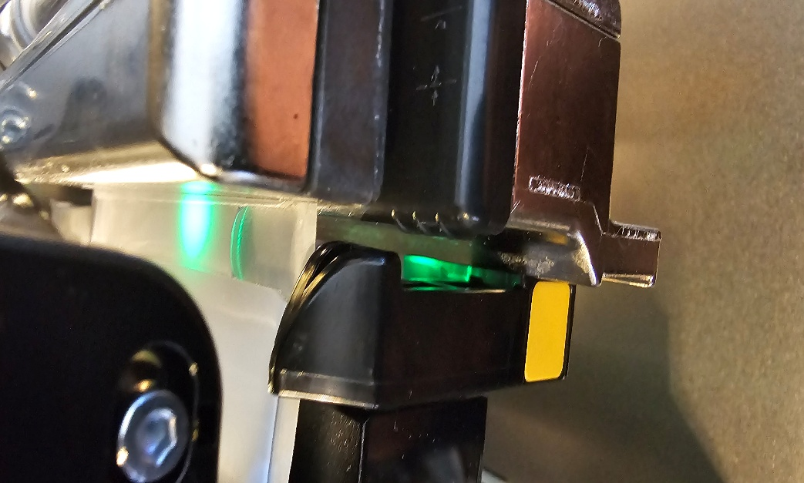
Close print head
Close printer door, Auto Calibration will start automatically.
Connect Printer
Select Menu/Connections then select type of connection and follow onscreen steps.

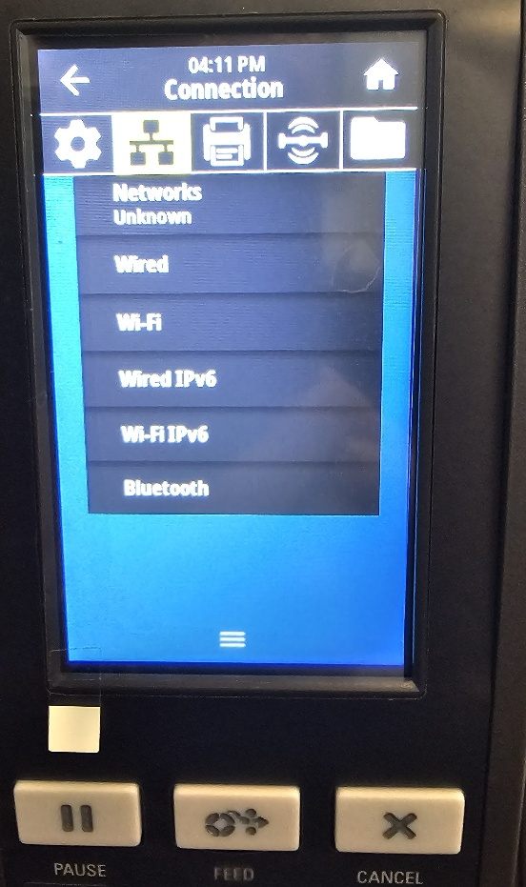
Select type of connection to find MAC/IP Addresses (If Applicable)

Troubleshooting
Does not print tag
1. Make sure printer power is on
2. Correct printer selected
3. Clear Printer Cache
4. Printer is connected to PC/Intranet
Tag is misaligned
Vertical adjustment will move the printed are up or down on the tag material.
Select Menu/Printer Icon/ Image Adjust/Vertical Label Offset
Pressing the minus will move the printing area up and pressing plus will move the printed area down. Adjust until printed area is centered.
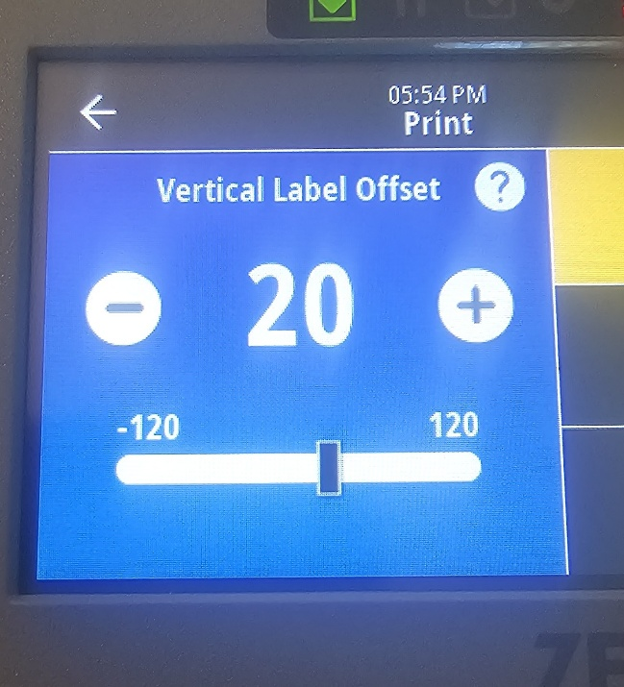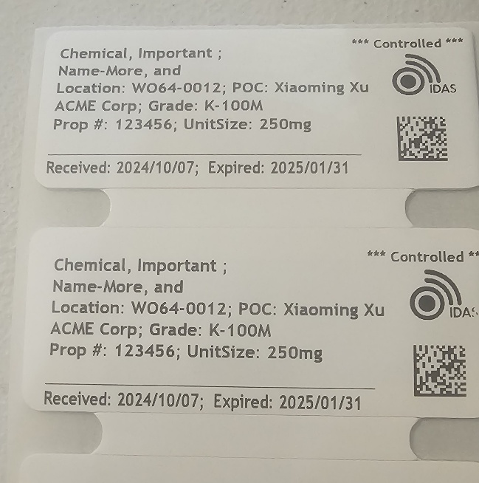

Horizontal adjustment will move the printed area left or right on the tag material.
Select Menu/Printer Icon/ Image Adjust/Horizontal Label Offset.
Pressing the minus will move the printed area to the right. Pressing the plus will move the printed area to the left.

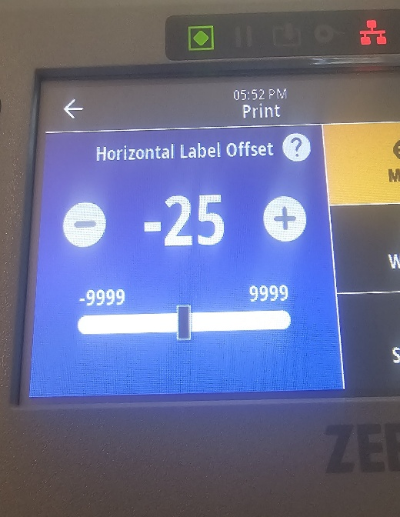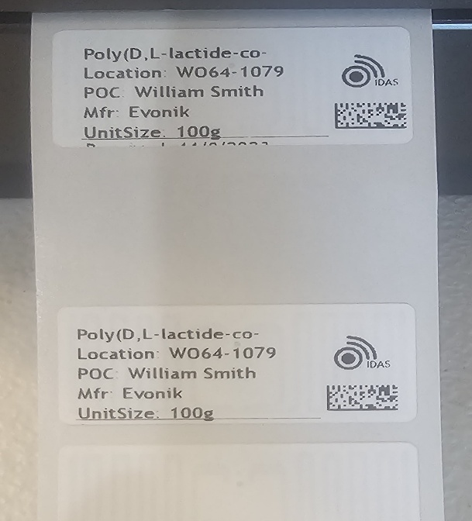

Tear Line Offset
This adjustment is used to to properly align tags for proper tear off after printing. Go Menu/Printer/Image Adjust/Tear Line Offset
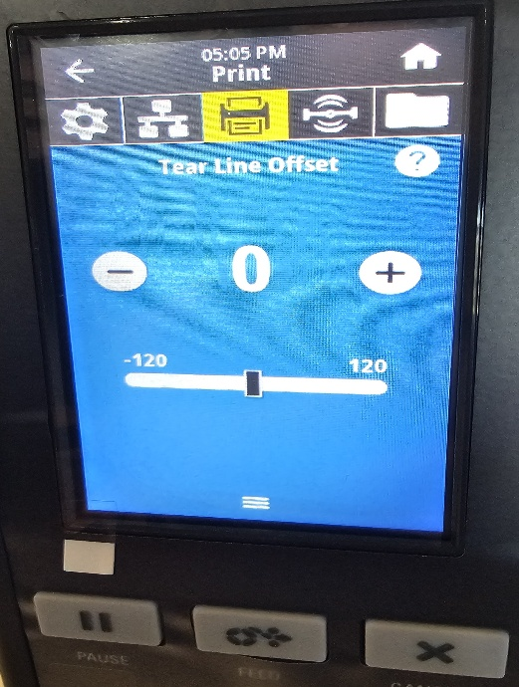
Negative will bring the tag into the printer while positive will push the tag outwards. You want the tear off at the end of the printed tag.
For the ZD621R the tag is pulled upwards to tear off the tag. Proper Tear Line Adjustment is shown below. There is little to no gap.
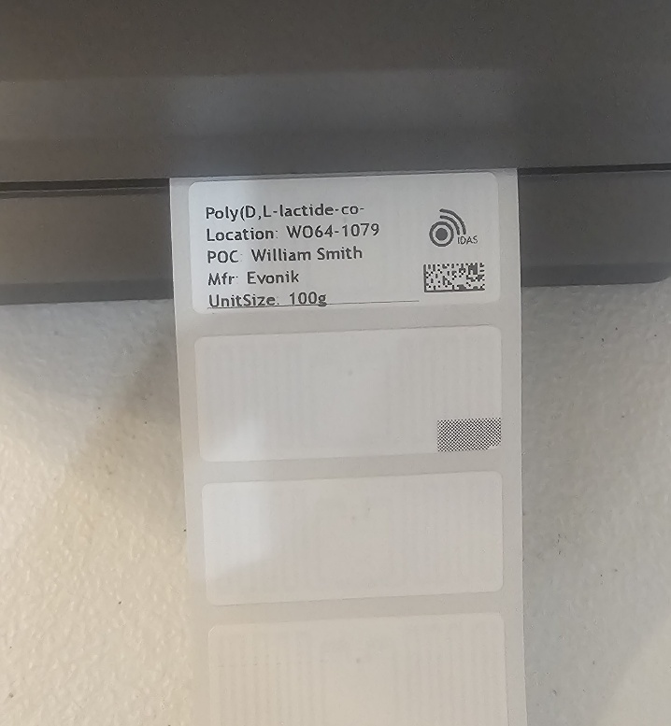
For the ZT411R the tear Line Offset is adjusted to line up with the tear off bar (Green Arrow). The tag is pulled downward to tear off. Proper Tear Line Offset is shown below.
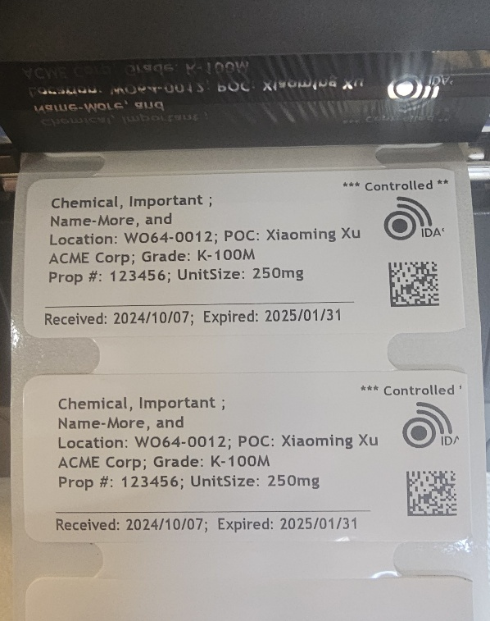
VOIDS
If tag prints with VOID across the label, this means there is an issue with Media Calibration or RFID encoding. This example is due to Media not Calibrated. If printing is centered then proceed with RFID Calibration.
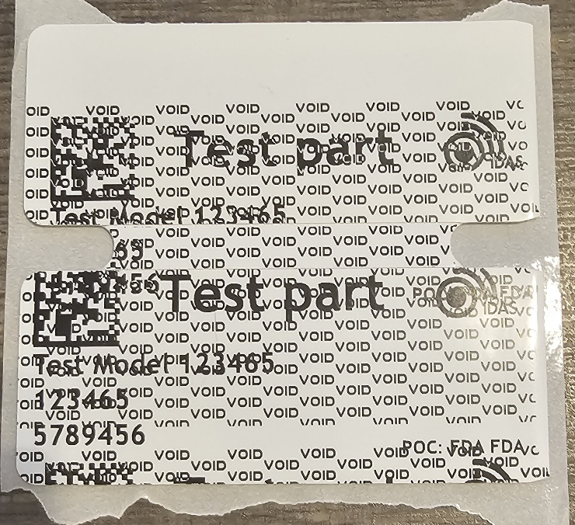
- First, make sure Media is calibrated correctly. Go to Loading Media and follow steps if needed.
- Complete RFID Calibration.
Select Menu/RFID Icon/RFID/RFID Calibrate
Select Start Calibration, calibration can take several minutes.

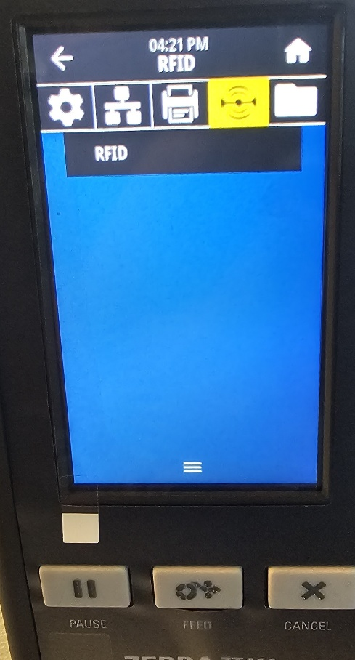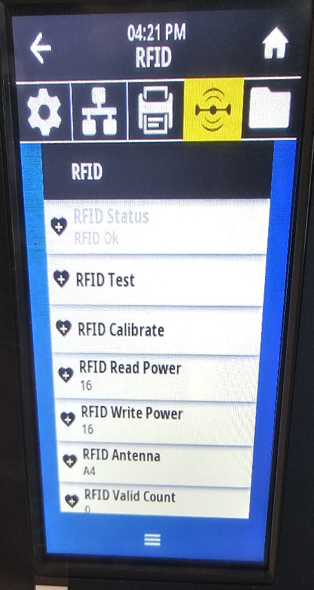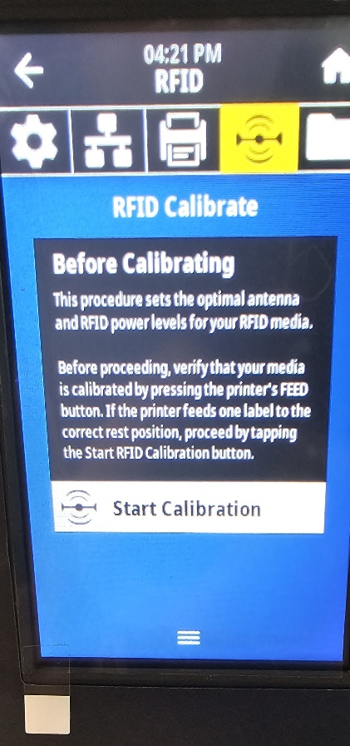
If problem persists lower RFID Write Power.
If no change, check data being sent to template is correct.

